LawTrak Class Guide

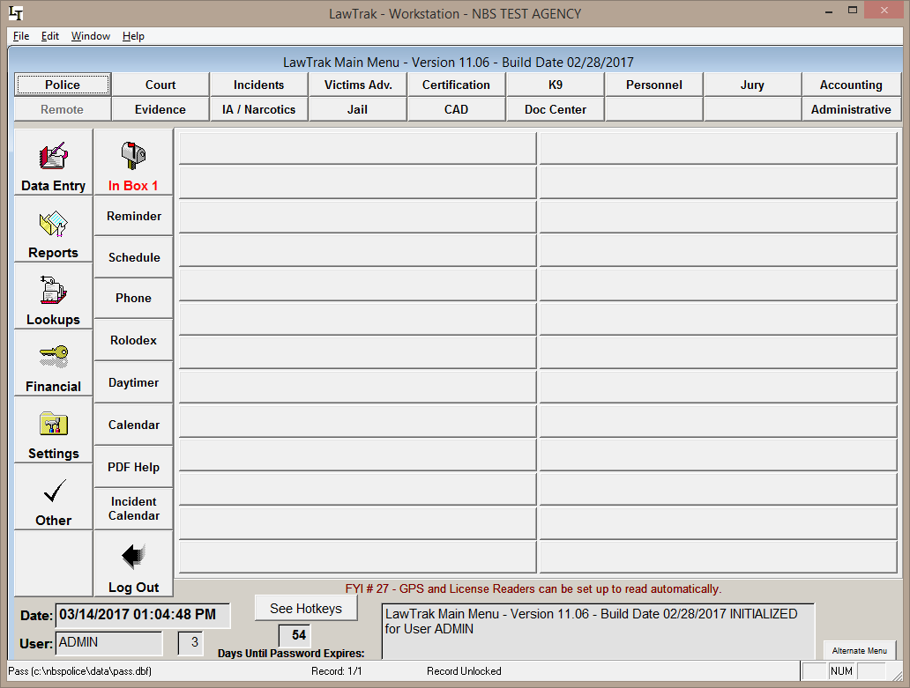

Main Menu

The main menu has the access buttons to all of the modules the user is allowed into, such as Court, Incidents, etc., important alerts to items that need to be addressed, as well as some additional optional modules available to everyone.
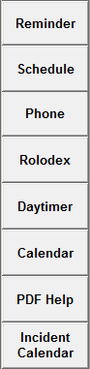
Most of the additional modules are hot-keyed, so you can access them at any time from anywhere in the program. For example, if you pressed F5 anywhere in the program, your personal Calendar will pop up. Once you exit the calendar page, you will be taken back to where you were in the program.

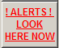
There is also an Alerts button that will let you know when routine maintenance needs to be done on the files, when your site license is about to expire, and other items that may need attention. Please pay attention to and fix any alerts that are displayed as soon as possible.

Additional alerts and warnings will pop up if you are an administrator in certain areas letting you know if monthly or yearly reports have not been run on time, and when it’s time to change various settings.

Shortcut Keys

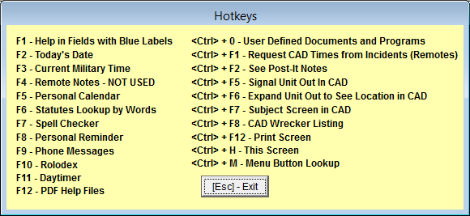

On the Main Menu, there is a button to See Hotkeys. This will bring up a screen showing you all of the keyboard shortcuts available in LawTrak.

There are a couple of shortcuts that rely on other programs to be installed before they will work. PDF Help Files require some sort of Adobe PDF reader be installed on the computer before it will open the help files. Print Screen only works when Microsoft Word is installed, and works best with versions before 2010.

For Your Information

On the Main Menu, FYI messages appear showing hints and little-known features in LawTrak.

Help Files

On most screens, you will see a small “Question Mark Button.” This signifies that there is a help file for the screen you’re currently on. If an Adobe PDF Reader is installed on your computer, you can press this button to pull up the associated help file.

