ADDITIONAL SETUPS
Warning / Alert Setup

Top Section: Administrative
Side Button: Data Entry

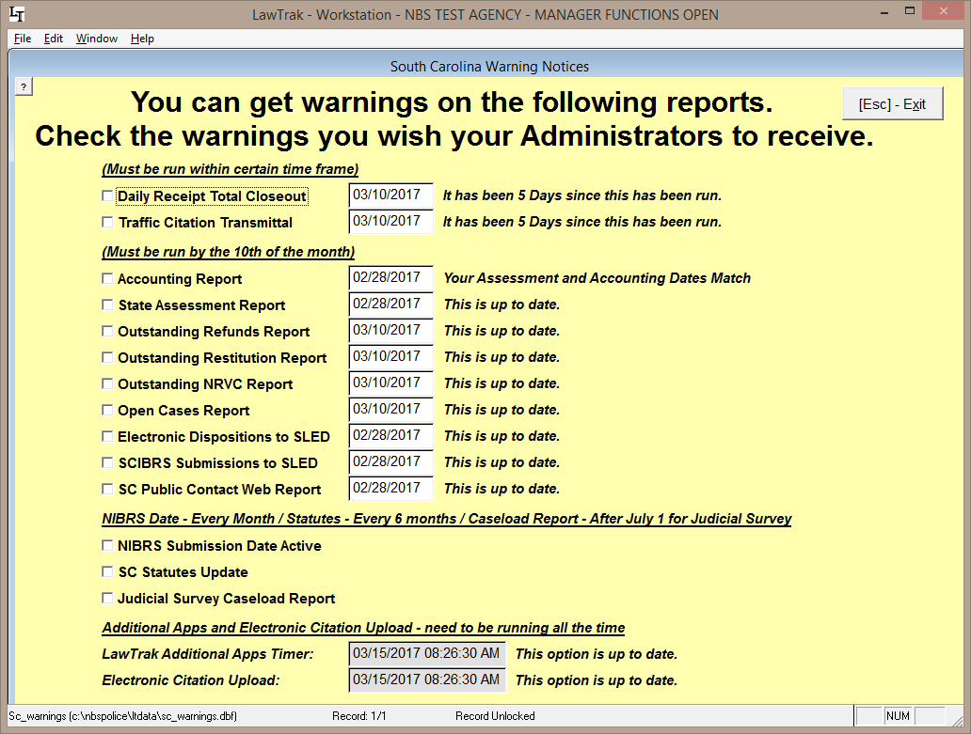

This option tells LawTrak which warnings to check to notify Administrators when they log in if something is not correct.

If the option is checked, the program will warn you if things are overdue. In this example, the Daily Receipts Total Closeout and Traffic Citation Transmittal have been checked. When an Administrator logs into LawTrak, they should receive a message similar to the one below.

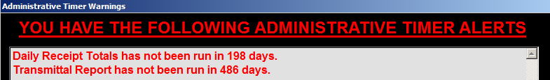

If you do not want warnings to appear, uncheck the options. If there is a warning that is vital to the program running correctly (i.e. Reindexing, Upgrading, etc.), the LawTrak will warn you whether alerts are checked or not.

