Officer Setup

Top Section: Administrative
Side Button: Lookups

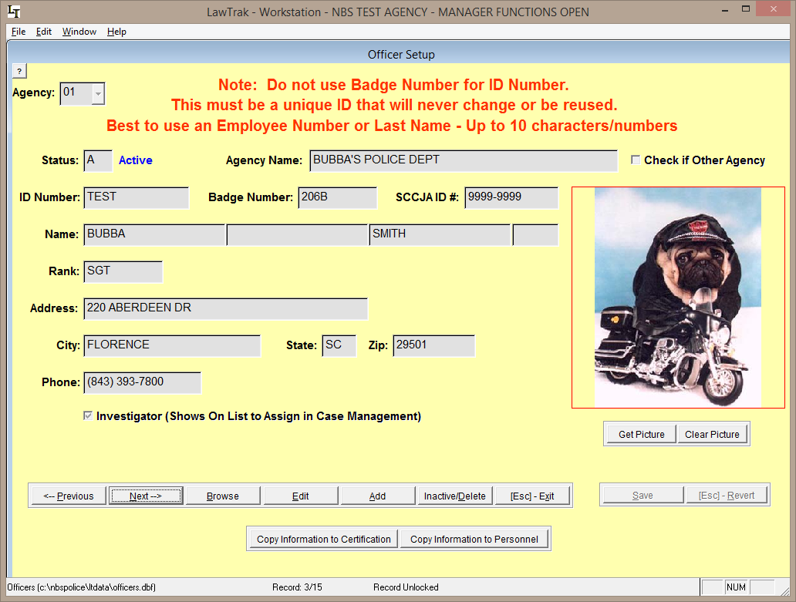

This screen will allow you to set up Officer Information. Each officer is assigned to a specific agency.

For the ID Number, we recommend you use a code that will not change (i.e. Name, State ID, Employee ID, etc.). Since Badge Numbers tend to be reused within an agency, it is recommended that the badge numbers not be used as the ID numbers.

Inactive/Delete: Pressing this key once will Inactivate an officer. Pressing the key a second time will mark the record for Deletion. Pressing it again will bring the officer back active.

If an officer code has records attached to it (e.g. Tickets, Incident Reports, etc.), you should leave the Officer ID in the database but mark it Inactive if the officer is no longer with your agency. Deleting the officer can create problems in running reports later. If you need to change the Officer ID so you can re-use the ID Number, see the Change/Merge Officer ID Numbers Help File.

If the officer is assigned cases as an Investigator, put a check mark in the box beside Investigator. The officer will then show up on the list of officers who can be assigned case in Case Management.

Once the Officer ID has been saved, you can utilize the buttons at the bottom to copy the officer information to the Certification and Personnel modules. This will start an entry into these modules with the Officer’s ID Number and Name. There is a lot of additional information needed for these other modules once the initial record has been created.

