SC State Statutes

Top Section: Court – Administrative
Side Button: Lookups – Data Entry

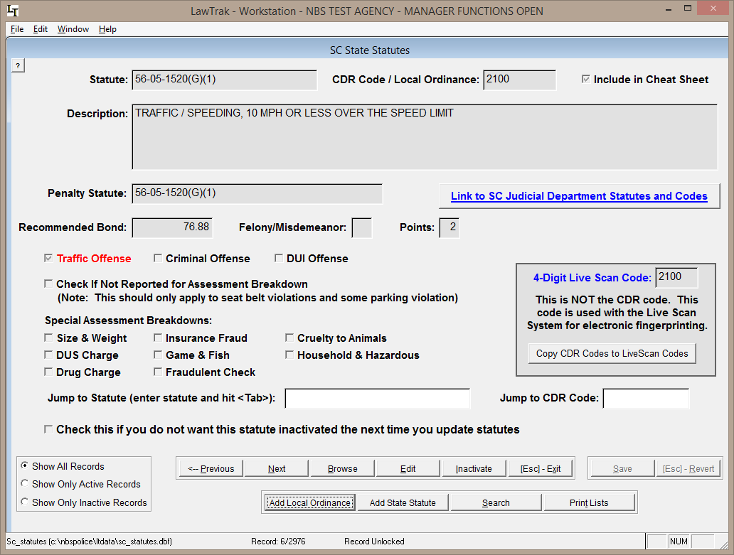

The SC State Statutes section contains records for all State Statutes that LawTrak uses, as well as any Local Ordinances you may want to put into LawTrak. Any time you fill in a ticket or warrant, it must be associated with one of the statutes in this file.

The Statutes are updated by a file from the State Court Administration, and contains all active statutes at the time the file was downloaded. Updates are done every 2 or 3 months, or when there are several statutes added or updated.

The South Carolina Statutes are in a format XX-XX-XXXX so they can be kept in numerical order. Local Ordinances are always given the state statute number 00-00-0000 and the local ordinance number is put into the CDR Code / Local Ordinance field.

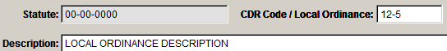
To add a local ordinance, press “Add Local Ordinance,” fill in the Ordinance Number and a Description. This will put the ordinance into the available statutes that can be used when filling out tickets and warrants.
It is possible to enter additional State Statutes. Please call LawTrak Technical Support to find out the rules on adding State Statutes.

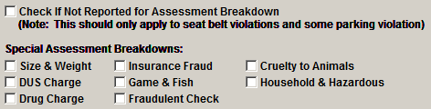
There is a section of Special Assessment Breakdowns for specific statutes. For the most part, LawTrak will know what to do with the individual statutes. The only time this needs to be adjusted is if you add a State Statute that is not in the normal file.

There is an option on the individual statute to “Include in Cheat Sheet.” This option will break the statute out into a “most commonly used” list that can be printed easily.

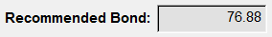
The Recommended Bond field can be filled in to automatically feed the Fine/Bond amount into tickets created when a specific statute is used. LawTrak does not calculate this amount when the statutes or fines are updated.

You can Inactivate a statute or local ordinance by pressing the Inactivate button. Statutes are not deleted from this screen unless it’s done by the upgrade function and the statute has never been used. Inactivating a statute keeps it from being used again, and takes it off of the statute list when searching from Tickets and Warrants. An Administrator can Reactivate an Inactive Statute.

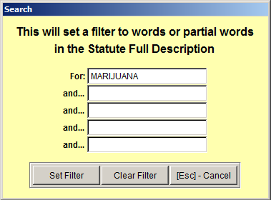
Searching for Statutes – Selecting the Search option will bring up a screen where you can fill in Search parameters. These parameters will look in the Full Description of the Statutes, and pull up any statutes matching the words or partial words being searched.

There is a hot-key short-cut that does the same sort of Search function on Statutes. Pressing F6 will bring up a similar screen from anywhere in the program. (See Statutes Help Screen Help File for more information)
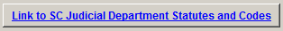
There is a Web Link to the SC Judicial Department Statutes and Codes page. If there is any question about a specific statute, this is the place to look it up.

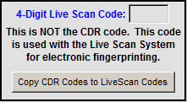
The section containing 4-Digit codes is only for use with a Jail’s Live Scan process. LawTrak works with some Live Scan systems and exports records from Booking Reports. If you tie a Live Scan code to a State Statute, this code is included in the export.

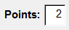
If there are license points associated with the statute and they are not already filled in, you can enter them. These will automatically pull into the Uniform Traffic Ticket and upload to DMV if necessary. Please note that you can also enter the points directly into the Traffic Citation if needed.

