Traffic Offense Code Setup

Top Section: Court
Side Button: Lookups

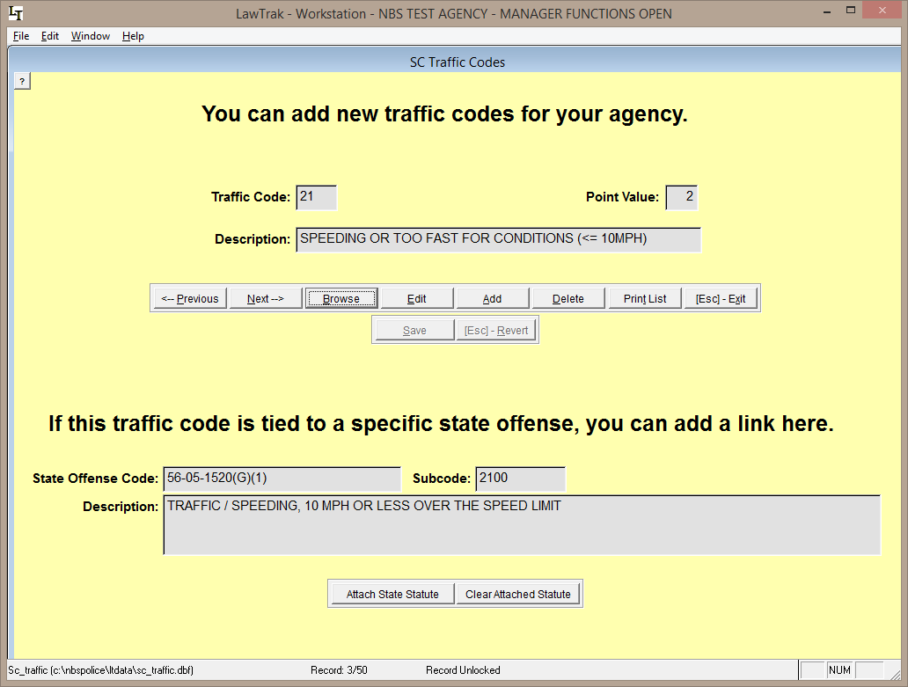

This file contains the list of Traffic Codes used on Uniform Traffic Tickets. You can add new codes to this list if your agency uses additional codes. You can also attach State Statutes to the codes to make filling in Tickets a little easier. Since the Uniform Traffic Tickets do not use the Traffic Codes any more, these are completely optional. They can be used as shortcuts for any type of offense – traffic, criminal, local ordinance – that you want to make a shortcut for.
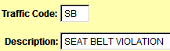
If you want to add an additional code, press the Add button, make up a 2-character traffic code, and fill in the description.

You can attach a State Statute to a Traffic Code. Doing this will cause the State Statute to automatically be filled in as you do a Traffic Ticket. You can also use this option to change the statute attached to any of the traffic codes.

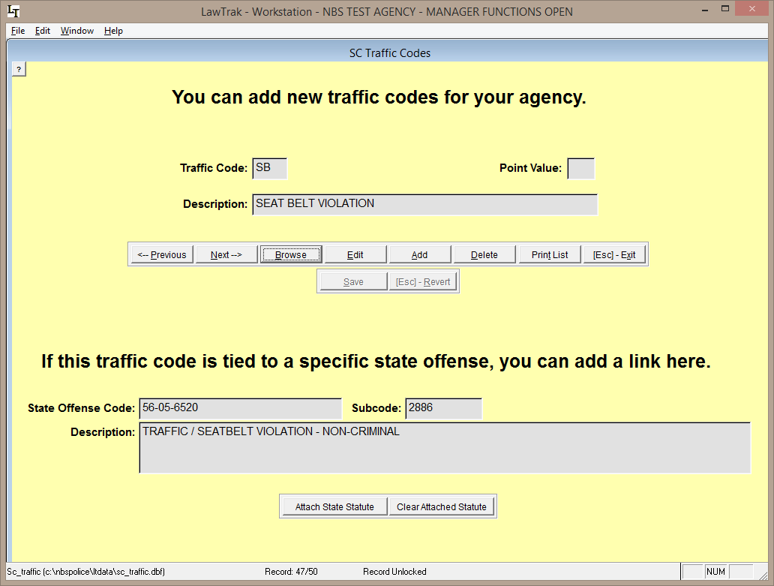

Pressing the Attach State Statute button will take you to a Find Statute screen. Search for the Statute or CDR Code and press the Select Statute button. (See Find Statute Help File for more information)

NIBRS Inhouse Code Setup

Top Section: Administrative
Side Button: Lookups

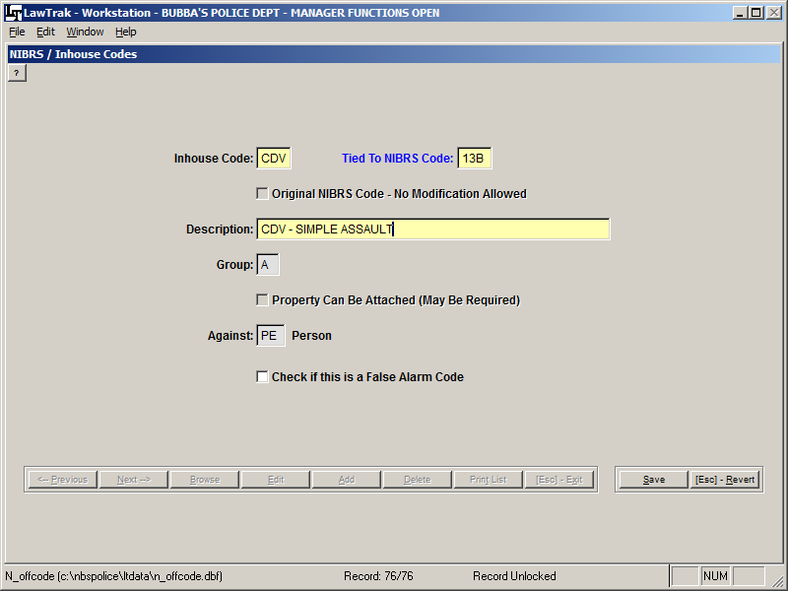

This screen allows you to add inhouse codes used in Incident Reports. These codes can be used to track specific types of offenses that may fall under a larger group.

In the example above, we make up a specific code for CDV, which normally falls under a 13B – Simple Assault code. If you use the CDV code in the incident report offenses, you can start tracking this code and get statistics very easily. If you do not use a specialized code and want to count CDV’s, you would have to print out all 13B codes and manually count the CDV codes within the 13B.

You can also make up codes for things that are normally not reported to SLED (i.e. DUS, Alarm Call, Warrant Service, Assisting Other Agency, etc.). Doing a simple incident report using these new codes will give you the ability to get quick counts to show how many your agency has done for a time period.

