NIBRS Inhouse Code Setup

Top Section: Administrative
Side Button: Lookups

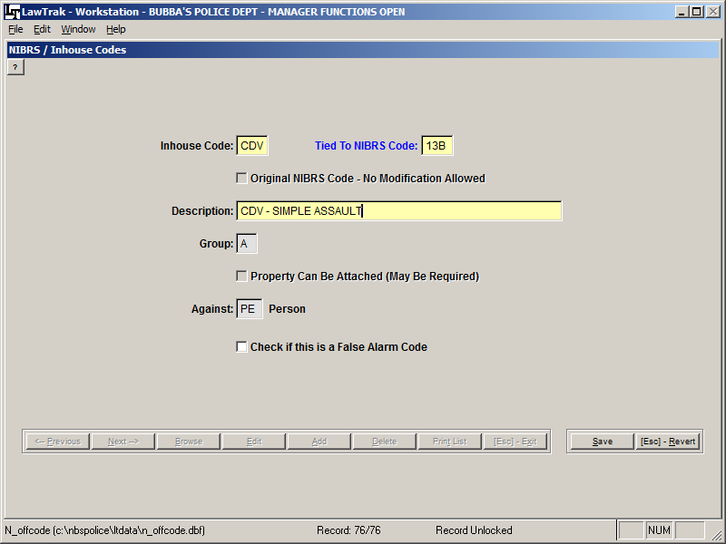

This screen allows you to add inhouse codes used in Incident Reports. These codes can be used to track specific types of offenses that may fall under a larger group.

In the example above, we make up a specific code for CDV, which normally falls under a 13B – Simple Assault code. If you use the CDV code in the incident report offenses, you can start tracking this code and get statistics very easily. If you do not use a specialized code and want to count CDV’s, you would have to print out all 13B codes and manually count the CDV codes within the 13B.

You can also make up codes for things that are normally not reported to SLED (i.e. DUS, Alarm Call, Warrant Service, Assisting Other Agency, etc.). Doing a simple incident report using these new codes will give you the ability to get quick counts to show how many your agency has done for a time period.

