Disposition Setup

Top Section: Court
Side Button: Lookups

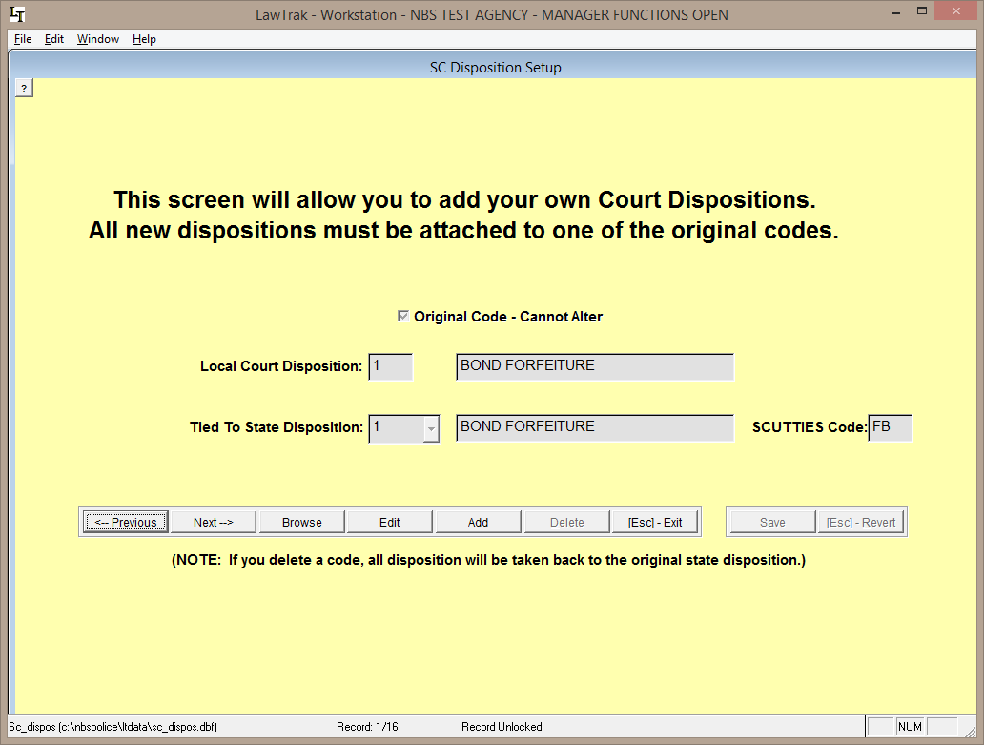

This file contains the list of the South Carolina Court Administration’s Disposition Codes. The main codes 1-9 cannot be edited or deleted.

New Disposition Codes can be added as long as you can tie them back to one of the original codes so that the Caseload/Disposition Report associated with the Judicial Survey can be run at the end of the fiscal year.
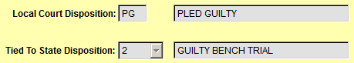
The new dispositions can have a code of 1 or 2 numbers/letters, and the description for the code can be whatever you wish. Tie the code back to one of the original state codes and press Save. You can make up as many disposition codes as you want.

