Custom Letter Setup

Top Section: Court – Parking – V.A.
Side Button: Lookups / Settings

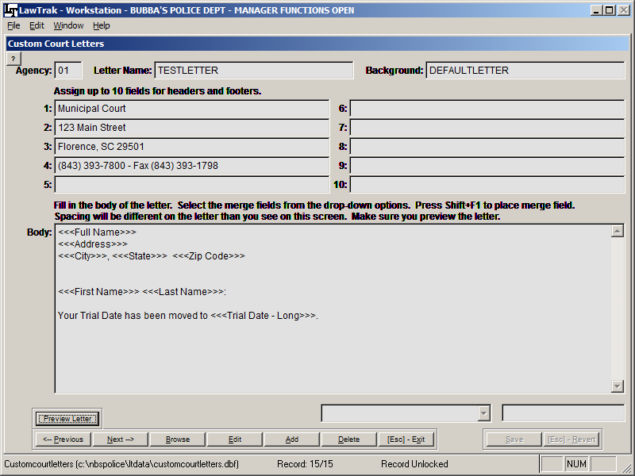

The Custom Letters can be found in many sections of the program. They allow the user to set up mail-merge documents for various types of letters to send out to defendants, attorneys, jurors, victims, etc. Each module has the mail-merge fields unique for that module, but all letters are created basically the same way.

Adding a New Letter

When you add a new letter, you will need to create a Letter Name. There should not be any spaces in the letter name. Some Custom Letters will also allow you to select a background. If you have a specialized background that was made up specifically for your agency, you can replace the Background name with that specialized background name. If you are unsure whether or not you have a customized background, please call LawTrak Support.

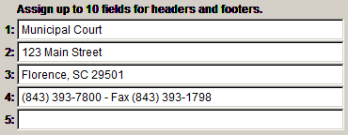
Depending on the background, you may have to fill in certain header / footer fields. The DEFAULTLETTER background can have up to six (6) lines for a letter head, and it automatically includes today’s date. You don’t need to fill in every header or footer line, and if you have a special background, these header/footer fields may correspond to something entirely different.
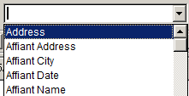
There is usually a drop-down box of some kind near the bottom of the screen. This drop-down contains all of the fields that can be merged into the letter. Depending on which module you are in, your choices will be different.

Depending on which mail-merge letter setup you are in, there will be instructions on how to get the drop-down field into the mail-merge letter. In this case, place the cursor where you want in the letter and press Shift+F1. Some other screens instruct you to press <Ctrl>+V.
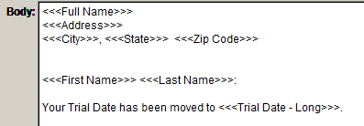
The merged field will be surrounded by <<< >>> signs. The fields can be placed anywhere in the body of the letter you wish.

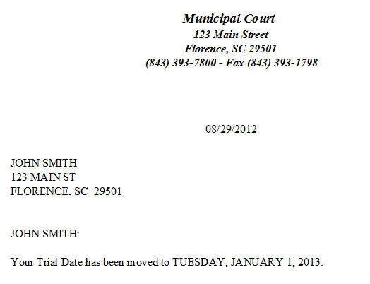
Once you have the letter formatted the way you want, press Save. In most cases, you will be able to Preview the letter to make sure it looks the way you want it to look. If you want to change the layout, edit the letter until it looks correct.

