Uniform Traffic Ticket Inventory

Top Section: Police – Admin
Side Button: Settings

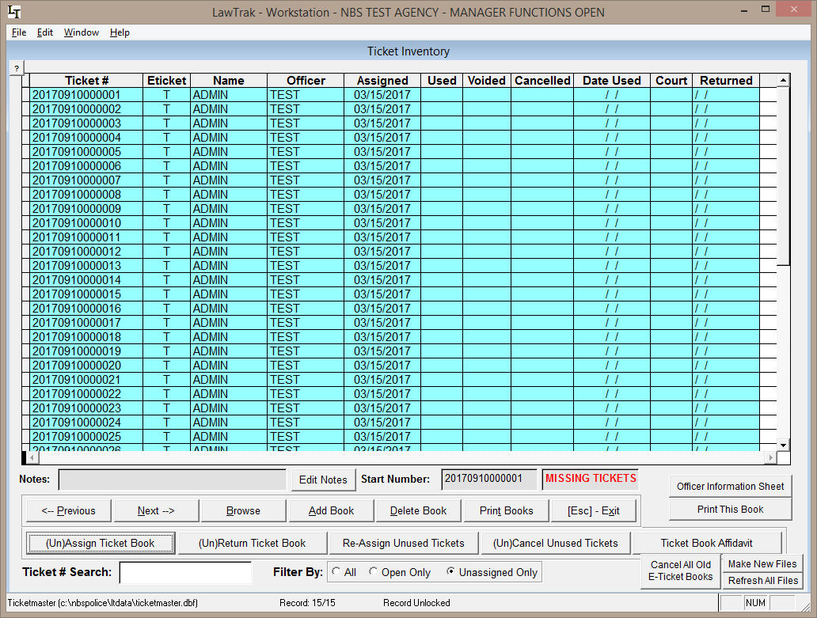

The Uniform Traffic Ticket Inventory screen is used to track tickets that have been assigned to officers. It is also used to give E-Ticket numbers to officers in the field.

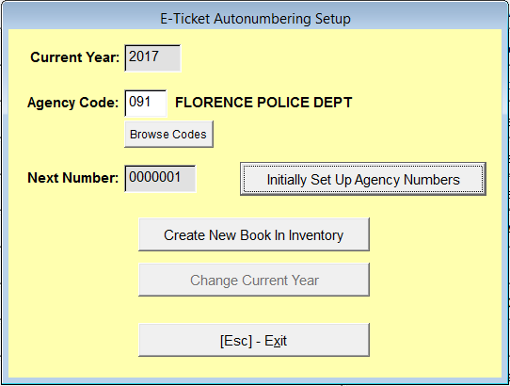
If you want to issue out a new E-Ticket block for a remote user, you must go to the E-Ticket Book Creation screen. This keeps track of the blocks that have been created in the Inventory, and is used to change the year on the blocks at the beginning of the new year. Simply create a new book in the inventory, and it will be ready to assign. You can create as many books as you need. Once created, assign the books out in the Ticket Inventory screen.

If you are assigning Warning Tickets, City Arrest Tickets, or Parking Ticket blocks, the process is a little different, but basically the same. Create the books and assign them out.

The grid tells you the ticket number, who it is assigned to, whether it has been used, and the ticket status in court. If the item on the grid is blue, that means the ticket has not been entered into the system yet.

