BASIC DATA ENTRY
South Carolina Uniform Traffic Tickets

Top Section: Police – Court – Remote
Side Button: Data Entry

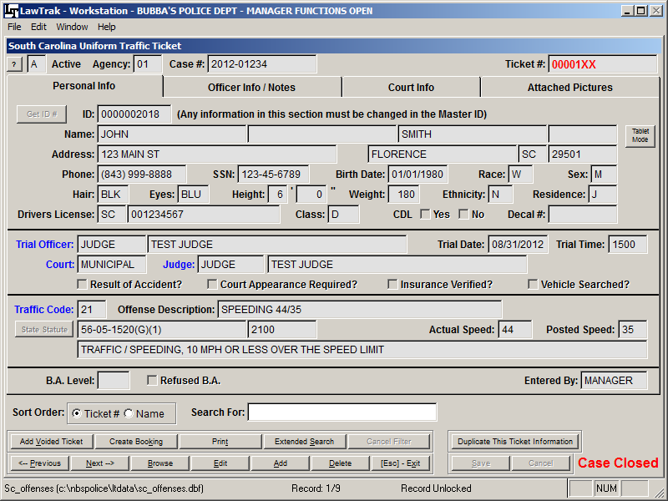

Adding a Traffic Ticket

There are two options to add a Uniform Traffic Ticket. The first is to Add a Voided Ticket. This will simply place a record in the file with the ticket number. No additional information is required.
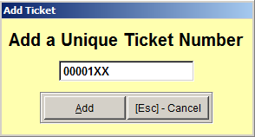
To add a ticket, press the Add button and fill in the Ticket Number. If you are working on a remote and have Automatic Ticket Blocks entered for E-Tickets, this number will fill in automatically. You can always overwrite the ticket number if needed. If the ticket number is already registered in LawTrak as being used, you will receive a message that you have entered an invalid ticket number.

NOTE: Special Fields

There are a few fields that are either mandatory or have special functions.

Any field that has a Yellow Background when adding or editing is a mandatory field. This type of field cannot be left blank.

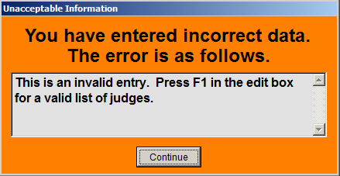
Any field that has a Blue Label next to it has some sort of Help Lookup. Most of the time, these fields can only take certain information set up in other files or mandated by the state. In most cases, pressing F1 while in this field will bring up a help screen with the valid entry information.

If you enter invalid information in any field with a blue label, you will get an error screen.

Once you enter the Ticket Number, you will be taken immediately to the Master ID Lookup screen. This is where you either select an existing person from the Master ID file, or create a new one. (Note: See Master ID Help File for more information)

To see if the person is in the system already, type in the LAST NAME, FIRST NAME in the Search box, press <Tab>, and see if you can find the person on the listing. You can also scan Drivers Licenses if you have a reader set up on the computer. Once you have the correct ID on the screen, press <Esc> to bring the information back into the ticket.

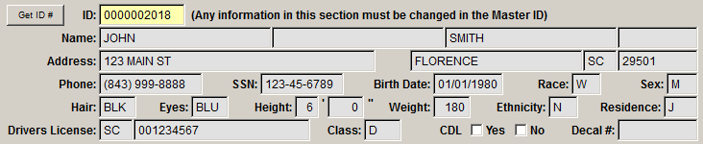

The information at the top of the ticket screen all comes from the Master ID screen. This section is only editable if you are on the Master ID screen. If any of this information needs to change, press Get ID #, go to the Master ID screen, edit the information, and press <Esc> to bring the corrected information back into the ticket.

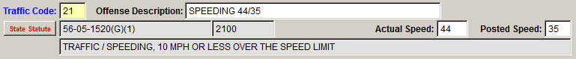

When you fill in the Traffic Code field, the default Offense Description is filled in as well. You can overwrite this field if necessary.

With some traffic codes, the State Statute is automatically filled in. These can be set up in the Traffic Code Setup.

If the State Statute is not correct or is missing, press the State Statute button to be taken to the Offense Lookup Screen.

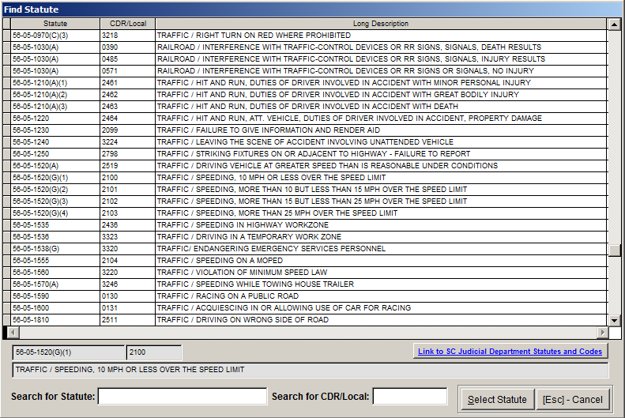

To find the correct State Statute or Local Ordinance, type in the statute number or CDR code and press <Tab>. You will be taken to the closest statute available. Once you find the correct statute, make sure it is highlighted by clicking on it in the grid and press the Select Statute option. This will transfer you back to the ticket and fill in the offense fields. All local ordinances have a state statute number of 00-00-0000. (Note – See the State Statutes Help File for additional information on adding new statutes and local ordinances)

Make sure you fill in all information on the Personal Info and Officer Notes / Notes screen, then press <Save>. Once saved, the ticket will automatically show up on the Court Docket and it will be available for connecting receipts.
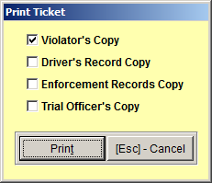
Printing a Ticket

You can print out the Uniform Traffic Ticket and all copies as needed. Simply select the copies you want to print.

Duplicating The Ticket Information

Once you have a ticket saved, you can press the Duplicate This Ticket Information to create another ticket for the same person, but with a different offense.

Attaching Pictures

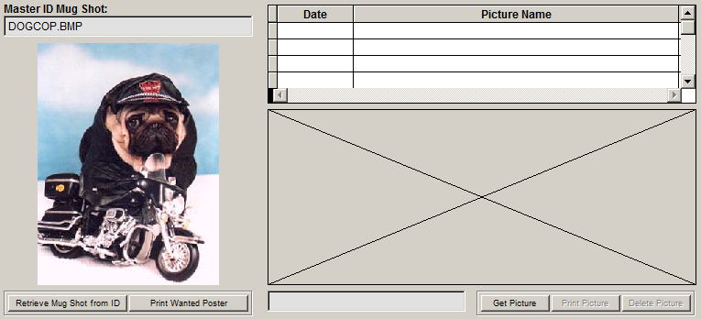

There are two types of pictures attached to a Traffic Ticket. The first type of picture is the Mug Shot. This comes from the Master ID record, and cannot be changed from the Ticket Entry pages.

The other type of picture is any type of picture you wish to attach to this case. You can attach as many pictures as you want. Pictures can be seen and printed if they are in the most common file formats (BMP, JPG, GIF, TIF, etc.). There is a size limit on how big the pictures can be. There are also limitations on what type of compression has been used while saving the picture (compressed TIFF, etc.). Try to avoid using extremely high resolution pictures.

Special Note about Case Number

If there is no specified Case Number, it will default to the Ticket Number. If the ticket is part of an Incident Report, you can overwrite the Case Number to match the Incident Report number. This will attach the ticket to the Incident Report and make everything easier to look up for a case.

Deleting a Ticket

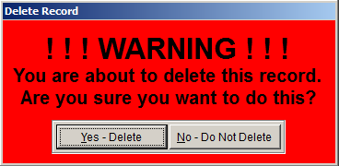
You can delete a traffic ticket as long as there are no receipts attached and the case is still open in Court. If there are receipts, a disposition, or a booking report attached to the ticket, you cannot delete it until everything attached is either deleted or moved.

South Carolina Arrest Warrant

Top Section: Police – Court – Remote
Side Button: Data Entry

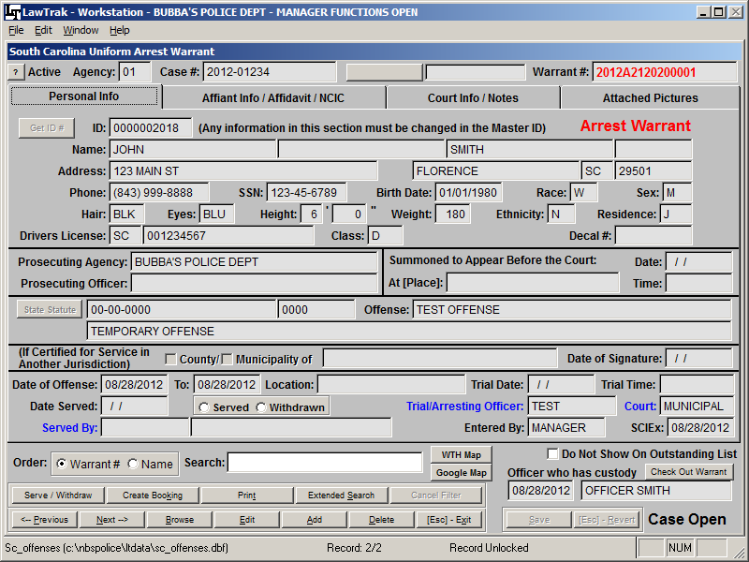

Adding an Arrest Warrant
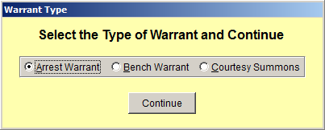
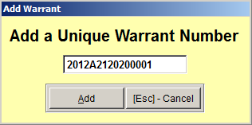
When you press the Add button, you will be asked what type of Warrant you are entering, then the program will assign the next warrant number in your agency’s block. If you are putting in an old warrant, or if you have a hand-written warrant, you can always overwrite the automatic numbering. If your agency has not set up the automatic numbering blocks, see Arrest Warrant Number Block Setup for more instructions.

Once you have a number, you can choose to attach a Warrant Template. This will fill in the state statute and start writing the affidavit automatically. (See Arrest Warrant Template Help File for more information)

If the Warrant is for service in another jurisdiction, fill in the appropriate boxes.

Fields for Courtesy Summons

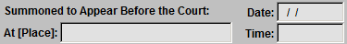
If you are entering a Courtesy Summons instead of an Arrest Warrant, some additional fields will open for edit. These fields will have a yellow background, normally meaning they must be filled in. However, since the Summons has not been served yet, there is no way to know the Summons Date. These fields can be left blank at the time the Summons is created, but must be filled in at the time the Summons is served so it can be taken to Court.

Affiant and Affidavit Information

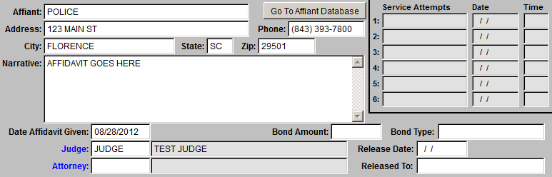
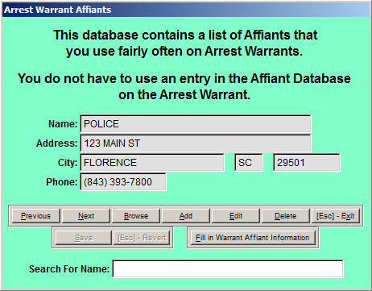
The Affiant Info / Affidavit screen allows you to put in additional information. There is an Affiant Database that is not connected to the Master ID file. This is designed specifically for those individuals or businesses which regularly sign out warrants (police department, businesses for bad checks, etc.). Using this section and keeping the entries fairly limited can help streamline the Affiant information.

If you do not want the Warrant to appear on the Outstanding Warrant List, select this option at the bottom of the Warrant Screen.

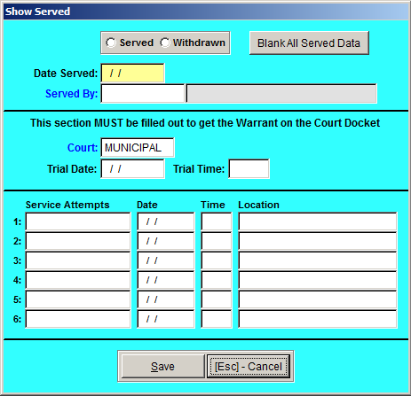
Serving / Withdrawing a Warrant

Once a Warrant has been saved, you can show it as being Served or Withdrawn. The Warrant will not show up on a court docket until it has been served and a Trial Date filled in. There is also an option to Blank All Served Data to bring the warrant back active, and spaces to fill in for Service Attempts.

If the Warrant is shown as Served and a Trial Date filled in, it will automatically show up on the Court Docket.

Checking Out a Warrant

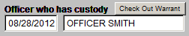
To help track who has actual custody of a Warrant, you can Check Out a Warrant and fill in the date and name of the officer who has physical custody of the Warrant. There is a report off the Main Menu which you can use to show who has custody of all Warrants. (See Outstanding Arrest Warrants Checked Out Help File for more information)

Printing a Warrant

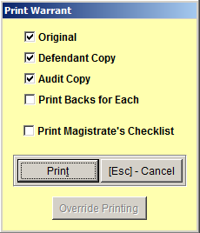
Warrants are printed out on a Laser Printer on regular white paper. You can print out the copies needed, as well as a Magistrate’s Checklist. The Backs for the Warrants can be printed out as well. If you print the backs, you will be prompted to put the warrants back in the printer. LawTrak does not support double-sided printing.

Once the Warrant has been printed, it takes an Administrator to override the settings to reprint it. This is to help keep duplicate originals from being printed.

Master ID File

Top Section: All
Side Button: Lookups

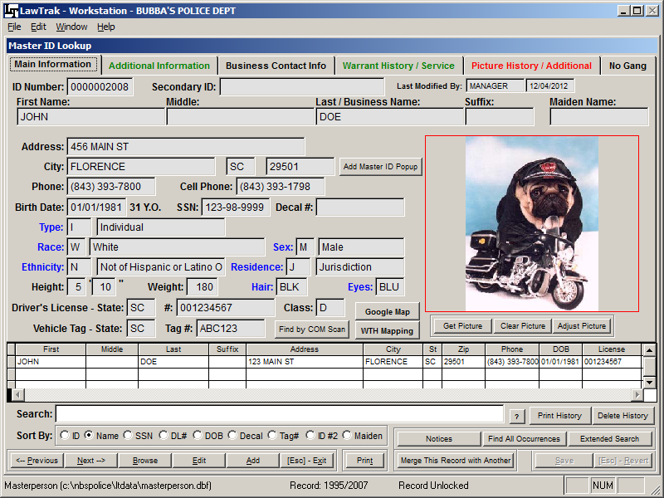

The Master ID File is where the personal information for every person entered into LawTrak is kept. All documents, whether from Court, Incidents, Tickets, Jail, etc., tie back to the Master ID File.

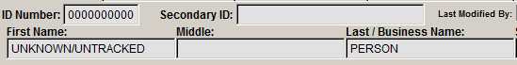
When you first enter the Master ID File, you start out with the Unknown/Untracked Person. If you are truly working with an unknown person, this is the ID you want to use instead of adding another Unknown into the file.

Searching the Master ID File
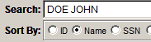
There are several ways to search the Master ID file. When you first enter the screen, you will be in the Search field. Type in the Last Name and First Name of the person you’re looking for and hit Tab or Enter. This will bring you to the closest name the program can find, and you can select from a list of names if there are more than one record for that name.
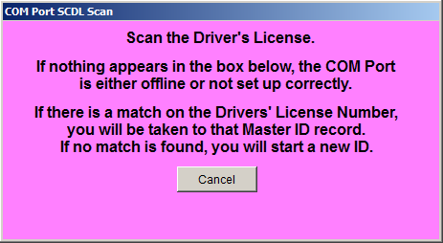
If you are working with Drivers License Scanners, you can also press the option to Find by COM Scan, scan the license, and the program will look for a matching Driver License Number or Exact Name Match. If a match does not exist, you can select to create a new Master ID record with the information on the license. There are also searches for Social Security Numbers, Drivers License Numbers, Maiden Names, Parking Decal Numbers, and License Tag Numbers, along with a few others. There is also an Extended Search option that will allow you to search for any field you want to search by (i.e. partial addresses, identifying marks, etc.).

If you cannot find the person in the Master ID file, press the Add button and fill in all of the data you have on that person.

If the person is in the Master ID file, but some information is different, press Edit and fill in the correct information. If something important on the record changes, LawTrak will add a “history” record near the bottom of the screen to show what the information used to be (i.e. address history).

Additional Information

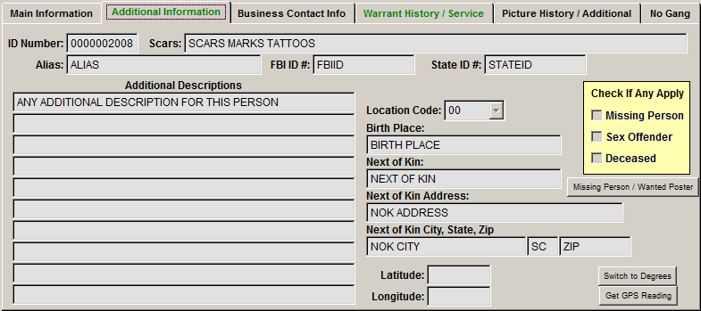

If you have additional information on the person, you can enter this on the second tab on the Master ID Screen. This can also contain the Latitude and Longitude if the entry is a Business instead of an Individual. If there is Additional Information on the record, the second tab will display in a different color to show you there is information on that page.

Business Contact Info

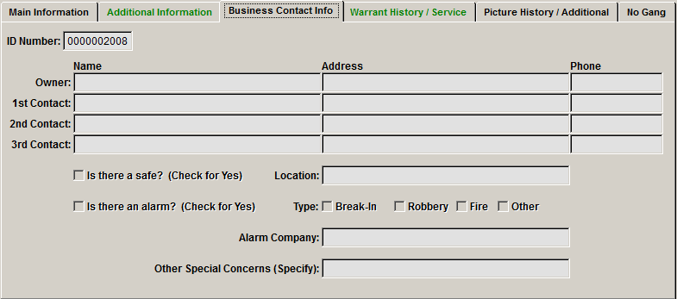

If the entry is a business, there is also a tab to enter things like Contact Information and Phone Numbers so you can find the information quickly.

Warrant History / Service Papers

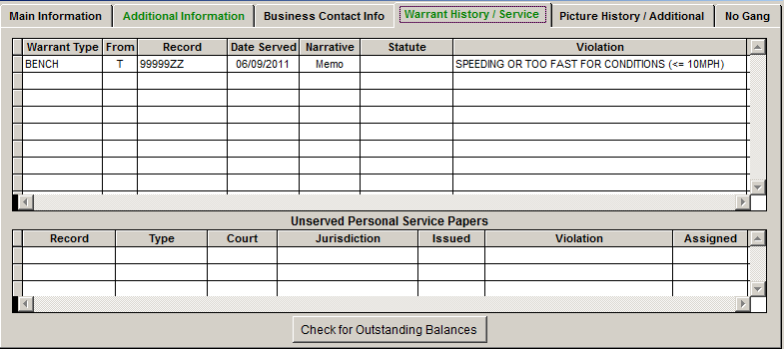

The Warrant History / Service tab will display a different color if there is information on that page. If the tab header is Red, there are Outstanding Warrants or Unserved Personal Service Papers listed for that person. If the tab header is Green, there is a history present, but nothing outstanding in the system at the moment.

Picture History / Additional Pictures

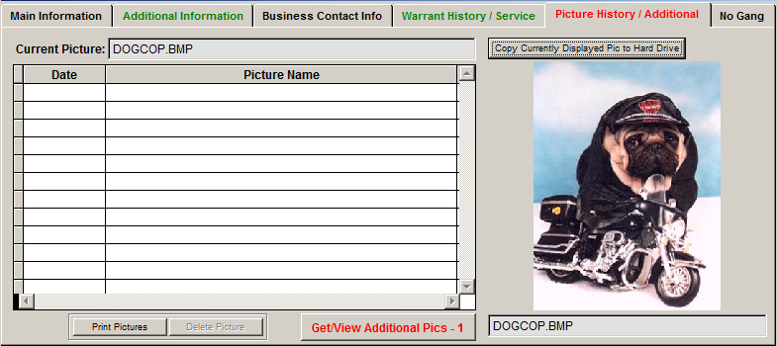
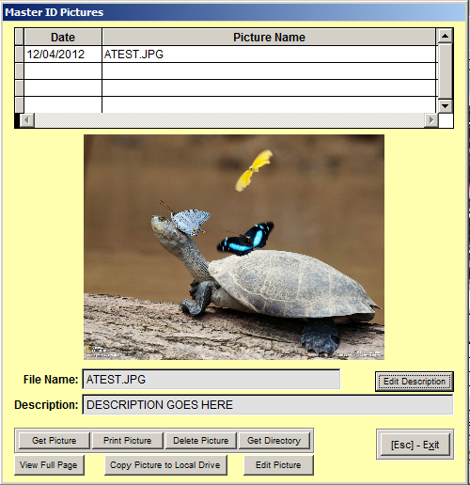
The Picture History tab will display a list of all Mug Shots from history. There is also an option to Get/View Additional Pictures. These would be pictures of anything having to do with the person (i.e. pictures of tattoos, buildings for businesses, or anything that could help identify the person.

If there is anything listed on the Picture History page, the tab header will turn red.

There is a link on the Main Information Page to add a Master ID Popup (see Master ID Popup Help File for more information).
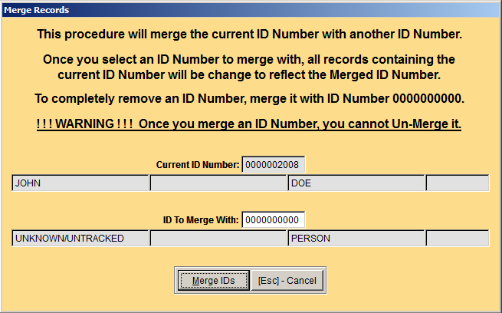
If you find a Master ID record that has been duplicated (two records with the same personal information exist), you can Merge the two ID records. Be very careful merging records, because once merged, it is extremely difficult to “unmerge” them if a mistake is made.

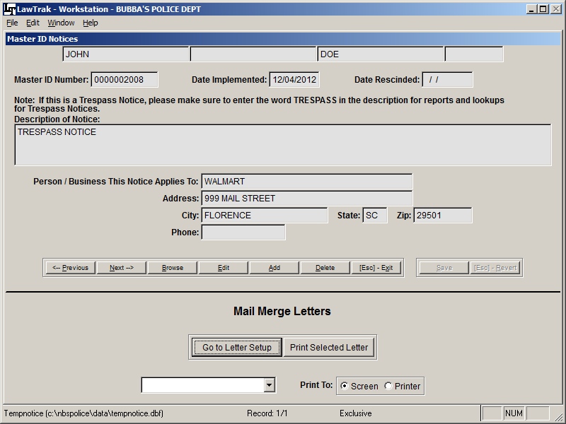

There is an option on the Main Information Page to add Notices. These can be used to keep track of things like Trespass Notices, Orders of Protection, or anything that you want an officer to be able to see very quickly.

Press the Notices button, press Add, and fill in the information. The notice will remain active as long as the Date Rescinded field is left blank, and the Notices button will display Active Notices in Red.

There is a place on the Notices page to create Mail Merge Letters to go along with the Notices (e.g. Trespass Notice Letter). (see Custom Letter Setup Help File for more information)

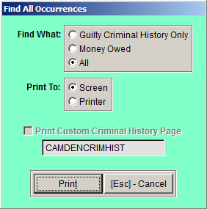
Find All Occurrences

There is an option to Find All Occurrences. This will allow you to see what type of history this person has in your data files. There are three types of history you can run.
Guilty Criminal History Only – This will display all Tickets and Warrants that have a Guilty verdict of some kind and closed in Court. This option also allows you to print the results on a special form that LawTrak Support can create for your agency.
Money Owed – This will display all court cases with Outstanding Balances.
All – This will display all instances of the person anywhere in LawTrak, whether on a Ticket or Warrant, an Incident Report, Parking Ticket, Warning, or any other type of document that would tie into the Master ID File.

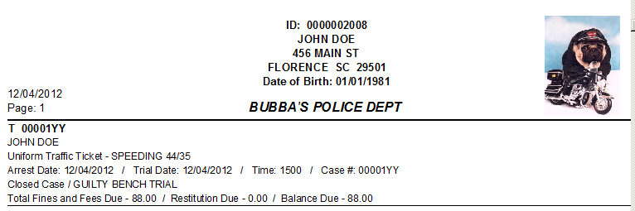
Coming From Another Part of the Program

Most of the time, you will be entering the Master ID Screen from another part of the program (ticket entry screen, incident report entry screen, etc.). Most of the time there will be a “Get ID” button on that screen, and you will be taken to the Master ID file to find the person or enter the person you’re looking for.

Once you have the person’s information on the screen, you will want to return to the original document so you can continue your data entry. Press the Exit button or press Escape, and you will be taken back to the original document, and the person’s information will fill into whatever document is needed.

