COURTROOM
Courtroom Proceedings

Top Section: Court
Side Button: Data Entry

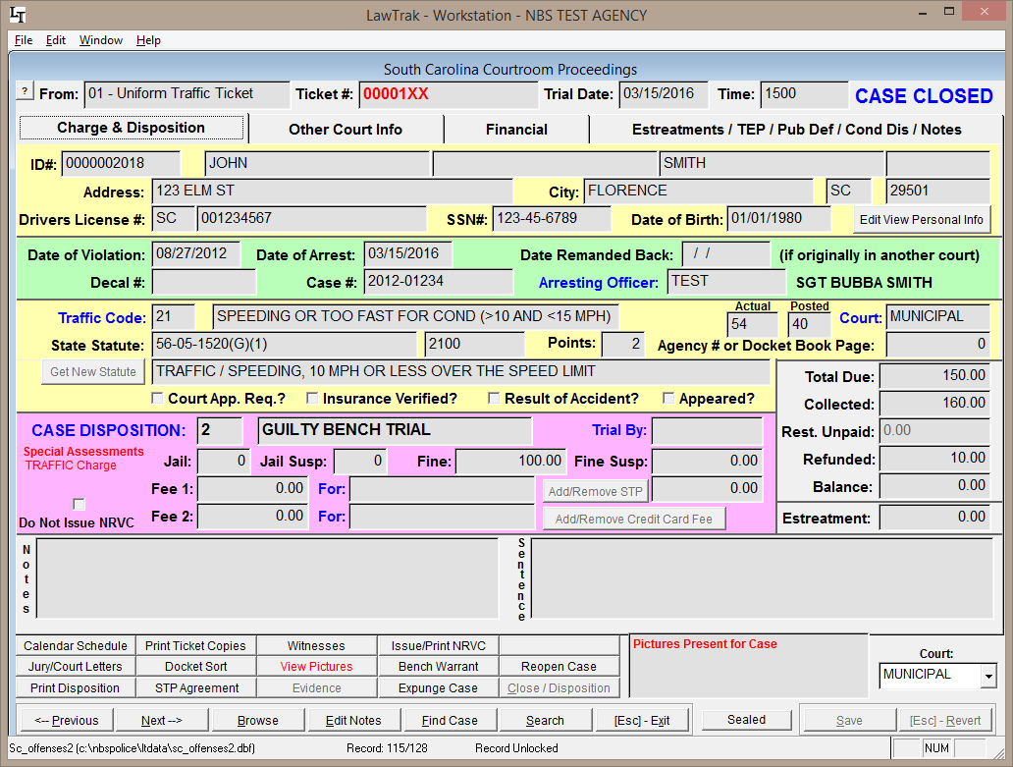

The Courtroom Proceedings screen is where most of the Court Clerk’s work is done. This screen handles everything from entering dispositions to taking payments to issuing Bench Warrants and NRVC’s.

As long as the case is Active, the Court Clerk can edit the court information for the Ticket or Warrant. Once the case is closed, the Court Clerk would need to reopen the case before any further edits are possible.

Since almost all court activities can be done from the Courtroom Proceedings page, there are a lot of functions we need to cover here. We’re going to start at the top of the first court screen and work our way down.

If there are Help Files for subsections of the Courtroom Proceedings page, you will be directed to those help files.

NOTE: Special Fields

There are a few fields that are either mandatory or have special functions.

Any field that has a Yellow Background when adding or editing is a mandatory field. This type of field cannot be left blank.

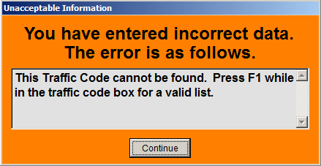
Any field that has a Blue Label next to it has some sort of help lookup. Most of the time, these fields can only take certain information set up in other files or mandated by the state. In most cases, pressing F1 while in this field will bring up a help screen with the valid entry information.

If you enter invalid information in any field with a blue label, you will get an error screen.

At the top of the screen, you get the basic information on the case you’re working with, including the ticket or warrant number, the trial date, and the trial time. It is vital that the Trial Date be set correctly. The Trial Date should be the date that the final disposition is set. If a case is continued for any reason, you should reset the trial date to the continued date, and make note of the previous trial date in the Notes or Sentence section. It is VITAL for monthly Assessment Reports and yearly Caseload / Disposition Reports for the Judicial Survey that this date be set correctly.

Also at the top of the screen you will see the Case Status. This basically shows you if the case is Active or Closed.

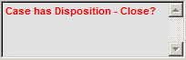
At the bottom right corner of the screen, there is a Message Box that may give you suggestions on what to do with the case.

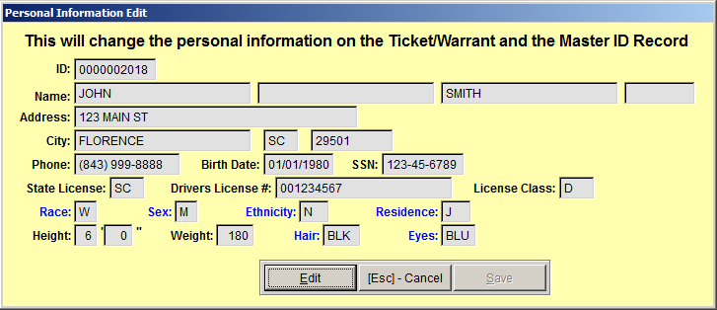
The next section shows you the individual information for the case you are working with. This information can be edited if necessary by pressing Edit View Personal Info. If you edit this information and save it, you will be prompted that this will change the Case Information as well as the Master ID record. Only use this if you’re sure the changes need to be made.

Date of Arrest

Date of Violation is not mandatory, but it is a good tool that the court clerk and judge can use to see how long it has been since the violation actually occurred. It is vital that you have the Date of Arrest filled in correctly. Most of the time, the Date of Arrest is used as the date the case was Filed In Your Court. This is mandatory information for the Caseload / Disposition Report. If the date of arrest is not correct, your caseload / disposition report could be inaccurate.

Date Remanded Back

The Date Remanded Back field should be used any time you have an old case that was written on a charging document from your agency that was originally sent to another court (e.g. General Sessions) that has been transferred or remanded back to your court. It is very important that this date be filled in if the case is transferred back to your court from another court, because this date will take the place of the Date of Arrest on the Caseload / Disposition Report.

Case Number

Be default, the Case Number will be the same as the Ticket or Warrant Number. If this case ties back to an Incident Report, you can fill in that number here. This will make it easier to look up all pertinent documentation tied to a case. If the Case Numbers match an Incident Report, anyone looking up the Incident Report can see Ticket/Warrant Dispositions associated with the same Case Number.
Arresting Officer

Even though the Arresting Officer is not vital information for court, it is important to fill this in correctly so that dockets will be printed in the correct order and your other reports are correct.

Selecting the Right Court

By default, any charging document that would normally go to court will be entered according to how you have your agency set up. If the case is supposed to go to another court (General Sessions, etc.), you need to change the Court. If a case is shown as being transferred to another court, it will not count in your Caseload / Disposition Report, and will not be counted as an Open Case for your court.

Traffic Code and State Statute
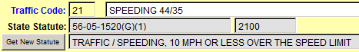
If the Traffic Code or the State Statute is incorrect, the Court Clerk can change either of these from the Courtroom Proceedings page. If the Judge changes the statute and you amend the ticket, you should change the codes to reflect the final charge.

Setting a Disposition

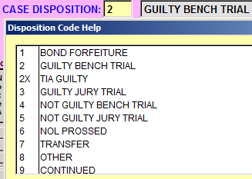
The dispositions are set to the South Carolina Court Administration’s Disposition Codes 1-9, plus one additional code for 2X, TIA Guilty. You can add additional disposition codes as long as you can tie those codes back to one of the 9 court Administration codes. (See the Disposition Setup Help File for more information)

To Close a case, you must have a final disposition set for that case. Dispositions tied to codes 7, 8 and 9 are NOT final dispositions, and the cases cannot be closed.

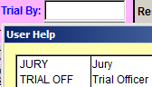
Trial By…

The Trial By box is basically used to designate when a case is set for Jury Trial. If the box is left blank, LawTrak assumes that it is set for Trial Officer. This field is also the trigger to print out on a Jury Docket.
Fines and Fees
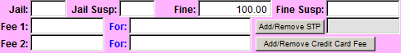
The Fine is the total amount being charged for the case. This includes the City and State portions of the final fine, as well as any of the mandatory fees and pullouts.

If the fine has been reduced, you can show the original fine and the suspended amount, or you can simply change the fine to the final amount. As long as the Fine minus the Suspended Amount is equal to the Final Fine Amount, either method will work.
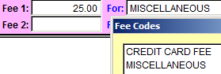
There are two additional fees that you can use. These fees should only be used if there are court costs for things that do not get assessed. These additional fees should not be used for the regular fine amount.

If the case is set up for Scheduled Time Payments, you should add the 3% STP Fee. You can also add this fee when you create the first receipt for the case.

If your agency is set up for Credit Card Fees, you can add this fee from the Courtroom Proceedings screen. (See Court / Additional Agency Settings Help File for more information)

Sentence Description

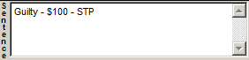
The Sentence box can contain anything the Court Clerk wants. It’s a good idea to make notes on every case – even the simple cases – to make looking up case information easier. It will also make audits easier to follow if there are notes pointing you to the right place or confirming dispositions and fines.

Other Court Information

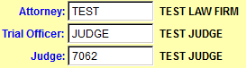
On the Second tab there are places for Additional Information. The fields for Attorneys, Trial Officer, Judge can be filled in for use in sorting dockets.

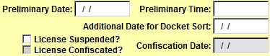
If there is a Preliminary Hearing scheduled, fill in the date and time. You can also use the Additional Date for Docket Sort for any other type of appointment you want to use it for. Both of these dates can be used for Docket Sorts. (See Docket Help File for more information)

There is also a place for the License Suspension / Confiscation and Date. This prompts the case to appear on the License Suspension Form for the Traffic Citation Transmittal Form. (See Traffic Citation Transmittal Form Help File for more information)

Community Service

If the court orders Community Service, you can fill in the Hours and Description. Hours Completed are entered in the Community Service Hours screen. (See Community Service Hours Help File for more information) If someone is ordered for Community Service, you should continue the case to the date they are supposed to be done so the case will come up again on a docket and you can put in a final disposition.

Other Information

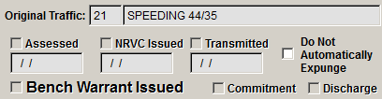
There is also a section showing what has happened to this case after it is closed as far as money being assessed, NRVC issued, ticket transmitted, Bench Warrant issued, etc.

Closing Cases

Once a final disposition has been put on a case, the case should be closed. Closing a case keeps it from being edited further, and allows other things to happen such as Assessments, Bench Warrants, and NRVC’s. It does NOT matter if the case has been paid. If there is a final disposition on the case, it should be closed.

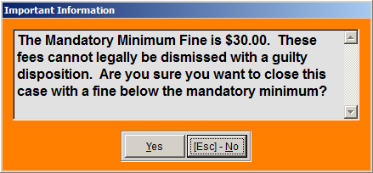
If you try to close a case with some kind of Guilty disposition, and there is not enough money in the Fine to cover the State Mandatory Minimum Fees, you will get an error message. LawTrak will let you do this, but there may be problems with Assessments later in the process.

Financial

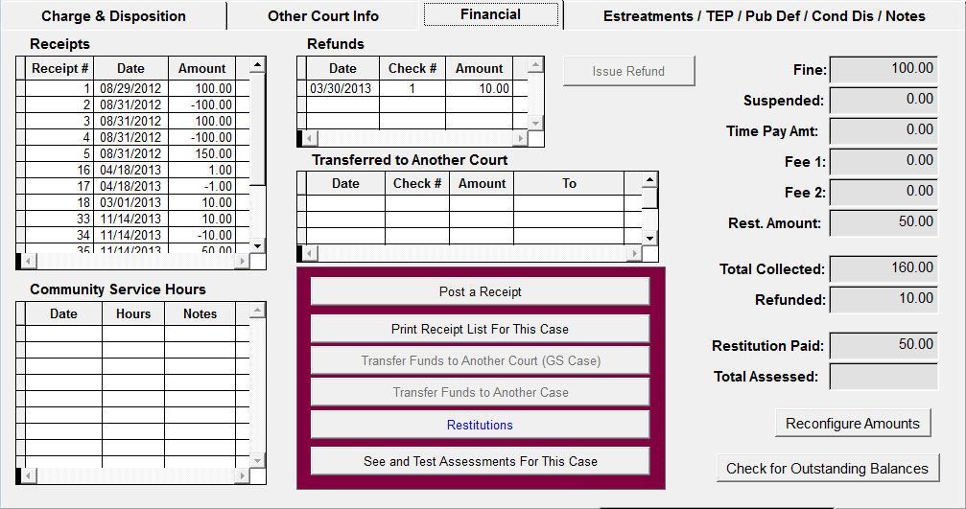

The Financial page shows all transactions available for the case, including the total fees, total amount collected, individual receipts, refunds, etc. This is also where the shortcut buttons are to post receipts, refunds, etc.

Estreatment / Traffic Education Program / Public Defender / Conditional Discharge

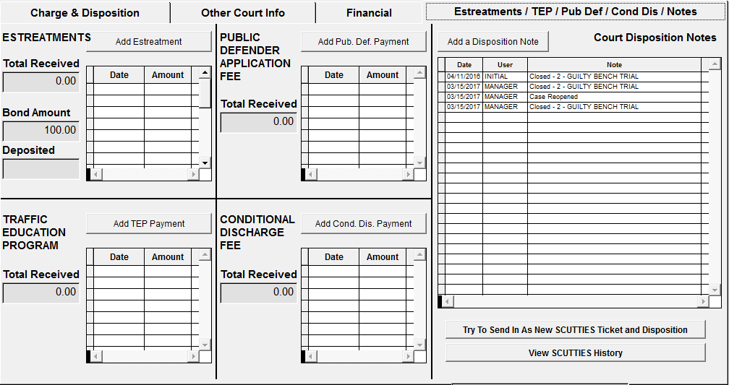

Since these payments do not go through normal Assessments, and they do not have anything to do with the actual Fine for the case, these payments are done separately. Basically, you press the button to Add whatever the type of payment is, LawTrak will take you to a page for that payment, and you add the payment. If it gets Assessed, LawTrak will place it on the Assessment Report for the month you take in the payment. Since these payments are not taken in as regular receipts, they do not show up on the Daily Receipt Totals. (See Estreatment, TEP, Pub. Defend., Cond. Discharge Totals Help File for more information)

Also on this screen are notes on when the cases are closed, disposed of but left open, reopened, etc.

Other Buttons

Issue/Print NRVC – This option will attach an NRVC (License Suspension) on cases where there is a fine that has not been fully paid on a Uniform Traffic Ticket. (See Issue/Print NRVC Help File for more information)

Restitutions – This will attach a Restitution to the case. (See Restitutions Help File for more information)

Print Disposition – This will print out a Disposition Sheet for the case.

Jury/Court Letters – This is a link to Additional Forms attached to a case. See below for a listing.

Receipts – This is a quick link to the Receipts page. (See Receipts Help File for more information)

Witnesses – This will allow you to list witnesses for the case while the case is open. Once closed, this will show you a list that is not editable.

Bench Warrant – This will create a Bench Warrant. (See Bench Warrant Help File for more information)

Issue Refund – If someone has overpaid on a case, this option will open up to issue a refund and print a voucher.

Transfer Funds / Court – If your agency takes in money for a case belonging to another court, use this option to transfer that money out. This will treat the transfer as a “refund” and take that money off the court’s outstanding bond reports.

STP Agreement – This will print out a STP Agreement for this case that the defendant should sign. It will also contain a list of receipts already in the system.

Print Ticket Copies – This will print out any/all copies of the Uniform Traffic Ticket if needed.

Reopen Case – If a case is closed and needs to be edited for some reason, an Administrator can Reopen the Case. When you reopen the case, you will receive a message that any funds sent for Assessments will be “Unassessed” until the case is closed again and Reassessed.

Docket Sort – This will put the Browse order into another order. If you print out a Docket with an order other than the default order, you can have the browse order match the printed docket order.

Expunge Case – An Administrator can Expunge a case, which will remove all personal information from the selected case.

Transfer Funds / Case – If receipts for a case need to be transferred to another case (i.e. a ticket is voided and rewritten on another ticket and the money collected needs to be moved), you can select this option and fill in the new case to transfer the money to.

Serve Warrant – If the Court tries to edit a Warrant that has not been served yet, this will open up a screen that will allow the Court Clerk to fill in the Service Date, Officer, and Trial Date so the Warrant can be taken into court.

Close Case – Once a final disposition is attached to a case and all fines/fees are in place, the case needs to be closed.
Jury / Court Letters

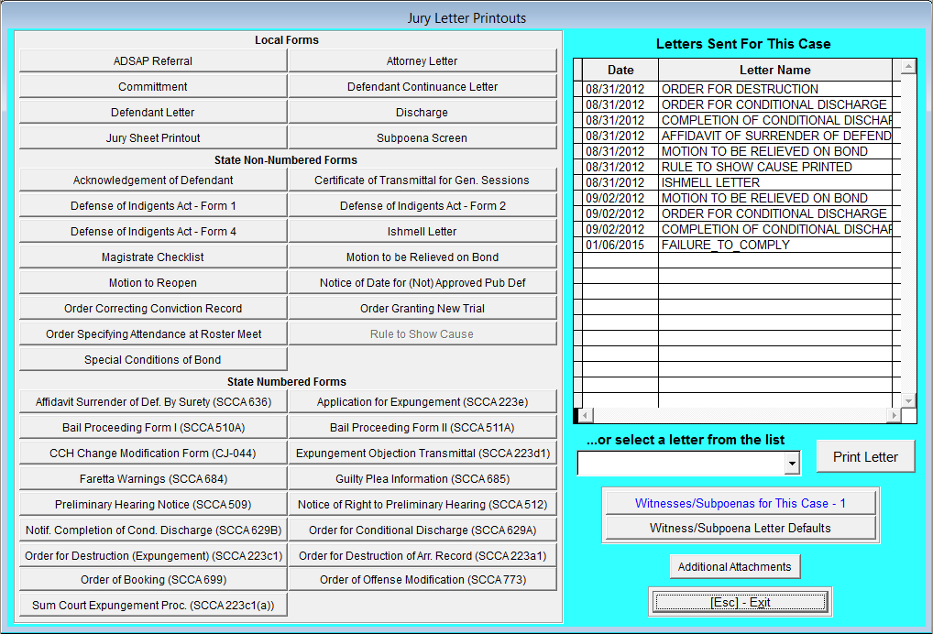

The Jury / Court Letters section contains additional letters and forms that can be attached to a case. If there is an entry screen, you will be directed to the appropriate Help File for more information.

You can also add Additional Attachments onto a case (scanned document, pictures, etc.) from this screen.

On this screen is also a list of the major printouts done for this case.

Print Custom Court Letter

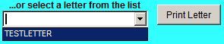
If you have Custom Letters created, you can print these out from the Case as needed. (See Custom Letters Help File for more information)
Witness / Subpoenas

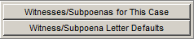
This section will let you set up a Mail Merge letter for Witness/Subpoena Letters.

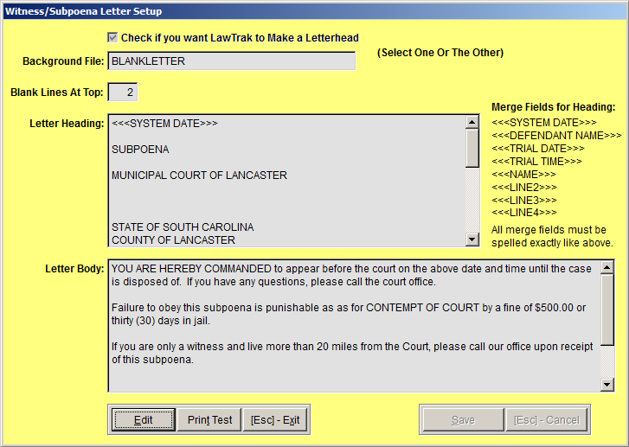
There is a default letter set up that you can modify as needed.
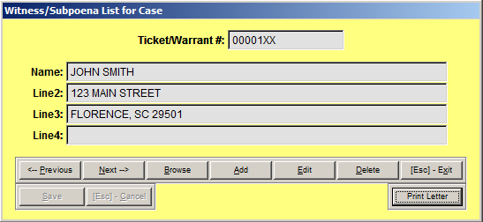

You can also enter Witness / Subpoenas for the case. You can print out the Letters from this screen. You can also print out the Witness/Subpoena letters from the Docket printout for the trial date. (See Dockets Help File for more information)

Defendant Letter – Attorney Letter – Defendant Continuance Letter – These letters are created in the Custom Court Letters, and attached to these quick-link buttons in the Court / Additional Agency Settings screen. (See Custom Letters and Court/Additional Agency Settings Help Files for more information)

Ishmell Letter – This will allow you to create an Ishmell Letter to send to the Court Administration allowing you to reopen the case if there is a problem with the disposition. (See Ishmell Letters Help File for more information)

Order Granting New Trial – (See Order Granting New Trial Help File for more information)

Order Correcting Conviction Record – (See Order Correcting Conviction Record Help File for more information)

Motion to Reopen – (See Motion to Reopen Help File for more information)

Preliminary Hearing Notice – (See Preliminary Hearing Notice Help File for more information)

Jury Sheet Printout – This will print out a blank Jury Sheet for the Court Clerk to work with.

Bail Proceeding Form I – (See Bail Proceeding Form I Help File for more information)

Bail Proceeding Form II – (See Bail Proceeding Form II Help File for more information)

Order of Booking – (See Order of Booking Help File for more information)

ADSAP Referral – (See ADSAP Referral Help File for more information)

Notice of Right to Preliminary Hearing – (See Notice of Right to Preliminary Hearing Help File for more information)

Order of Destruction (Expungement) – This will print out an Order of Expungement for the selected case.

Expungement Objection Transmittal – This will print out an Expungement Objection Transmittal for the selected case.

Magistrate Checklist – This will print out a Magistrate Checklist for the selected case.

Subpoena Screen – (See Subpoena Screen Help File for more information)

Order for Conditional Discharge – (See Order for Conditional Discharge Help File for more information)

Notice Completion of Cond. Discharge – (See Notice for Completion of Conditional Discharge Help File for more information)

Affidavit of Surrender of Defendant by Surety – (See Affidavit of Surrender of Defendant by Surety Help File for more information)

Motion to be Relieved on Bond – (See Motion to be Relieved on Bond Help File for more information)

Commitment – (See Commitment Help File for more information)

Discharge – (See Discharge Help File for more information)

Rule to Show Cause – Prints out a Rule to Show Cause form for the selected case.
Bench Warrant

Top Section: Police – Court
Side Button: Data Entry
Court – Courtroom Proceedings

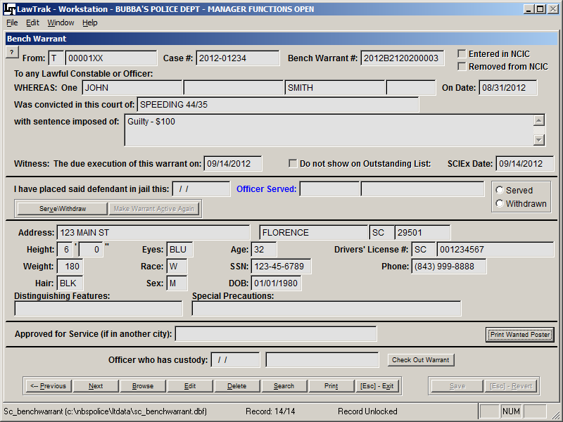

Bench Warrants are created from the Courtroom Proceedings screen once a case is closed. The information is filled in from the case, but you can edit the Bench Warrant once it has been created if you go to the Bench Warrant from the Court Case.

If you go to the Bench Warrant from Main Menu instead of the Court Case, you will be very limited as to what you can edit. The main thing to edit will be when the Bench Warrant is Served or Withdrawn.

When you press the Serve/Withdraw button, the Date, Officer and Served/Withdrawn options open. This will take the Bench Warrant off of the Active Warrant listing. Once served, you can also choose to make the Bench Warrant Active again.

If a Warrant has been checked out to a specific officer, you can fill in this section and pull up the Active Warrants for that officer.

Even though this section applies a State Bench Warrant Number to Bench Warrants created from the Courtroom Proceedings page, this Bench Warrant cannot be taken to court. This type of Bench Warrant is connected to another type of case (Ticket, Warrant, etc.).

If you want to create a Bench Warrant that will be the primary document to take to court, you can enter that in the Arrest Warrant section.

Issue/Print NRVC

Top Section: Court
Side Button: Data Entry – Courtroom Proceedings

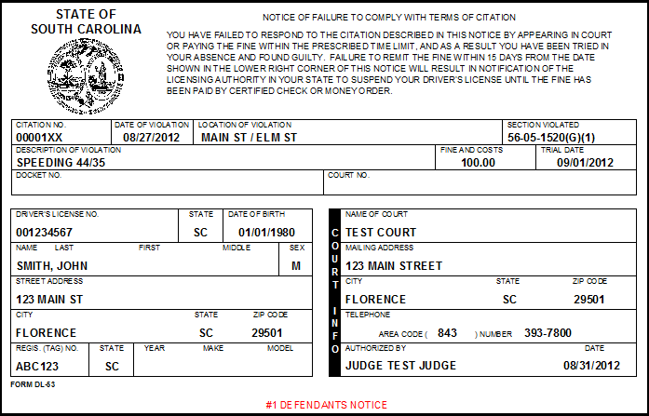
NRVC’s are issued from the Courtroom Proceedings screen. To issue an NRVC, the ticket must have a disposition of Guilty (whether by Bench Trial or Jury), and there must be an Outstanding Balance due on the case.
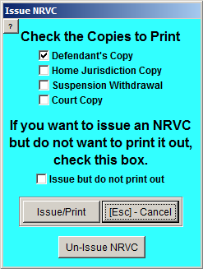
When you select to Issue/Print the NRVC, you can select which copies to print out. All NRVC’s are printed out on regular paper and should be printed from a laser printer. The old tractor-feed dot matrix NRVC’s are no longer supported in LawTrak.

If you still want to write out NRVC’s by hand, there is an option to allow you to issue them in LawTrak but not print them out.

Best Practices for Handling NRVC’s

1) Issuing: When the Court Clerk is entering Dispositions, it is pretty obvious which case gets an NRVC. When you close the case, issue the NRVC and print out the Defendant’s Copy. Mail the Defendants their copies.

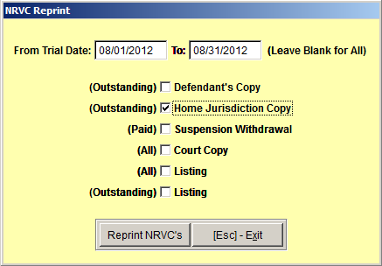
2) Sending To The State: After you wait the appropriate number of days after sending the Defendants’ Copies (at least 15 days), you can go to the report Court – Financial – Reprint the NRVC’s for Date Range. This will allow you to print all of the NRVC’s that have not completely paid that were issued for a date range. These are the NRVC copies you send to the state for License Suspension.

3) Printing The Withdrawal: Once an NRVC has been paid, a button at the bottom of the Receipts page (Either Court – Financial – Receipts or the direct link from Courtroom Proceedings) will become active so you can print out the Withdrawal (called the Blue Copy) directly from the receipt.

Restitutions

Top Section: Court
Side Button: Data Entry – Courtroom Proceedings

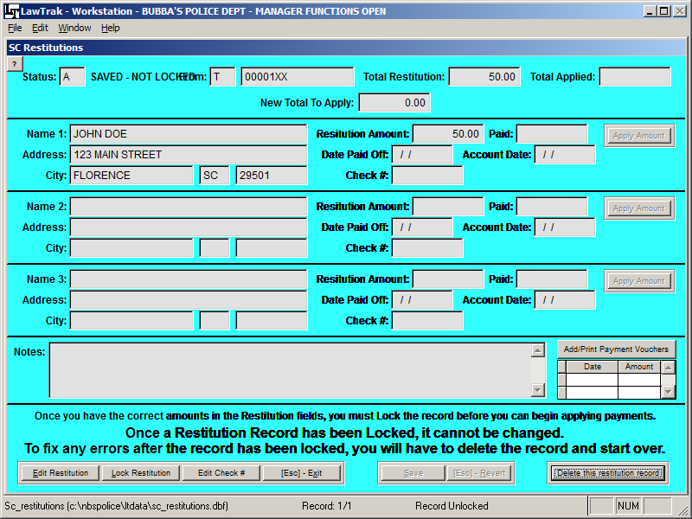

Once a case has been closed in Courtroom Proceedings, an option to attach Restitutions will be enabled. This will take you to a blank Restitutions Entry screen where you can fill in the information and amounts for Restitutions attached to a specific case.

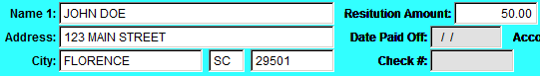
You can enter up to three separate restitution amounts for a case. Once this information has been filled in, press Save. This will change the status to Saved – Not Locked. This means that while the information has been saved, nothing can be done with it and it won’t show up on any reports until the restitution record has been finalized and locked. This is similar to Closing the Court Case.

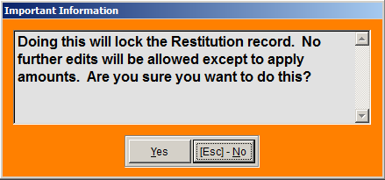

Locking a Restitution Record attaches it to the case, and makes restitutions amounts part of the overall fine to collect. Until a record is locked, nothing in the restitution record will show up on the case. Once the record is locked, the Status will changed to Locked, and no further edits will be allowed on the restitution. Locking will also allow money to be applied to the Restitution Amount owed.

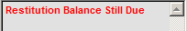
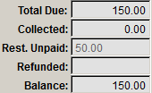
If there are any outstanding locked restitution records attached to a case, the link on the Courtroom Proceedings page will be red, and a message will appear in the Message Block to remind you that restitutions are still due. The outstanding restitution amount will also show up in the quick totals on the main Courtroom Proceedings page, as well as the Financial page.

Once a restitution has been paid off, the Restitutions button will turn blue, and there will be nothing in the Restitution Unpaid amount.

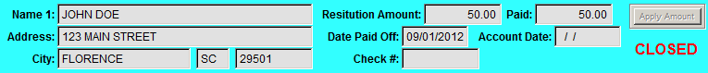

When money has been collected on a case, there are a couple of ways it can be handled. Most of the time, money collected will automatically attach itself to the Restitution Amount Owed first. If you have this switch turned off (See Court / Additional Agency Settings Help File for more information), or if the restitution was created after the money was taken in, you may have to manually apply it. The general rule of thumb for money collected: If money is applied to restitutions, it cannot be assessed. If money has been assessed, it cannot be applied to restitutions. To manually apply any money collected, go back to the Restitutions screen and press the Apply Amount button to move any available money down to the restitutions. Once the entire amount has been collected for an entry, the entry will be closed.

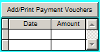
Payment Vouchers

LawTrak is designed to dispose of Restitution payments once the entire amount has been paid. If you want to pay out restitution money as it comes in, or some time other than when it is completely paid, you can keep track of these payouts by creating Payment Vouchers. This does nothing as far as LawTrak is concerned, but it will give you a paper trail if you want to pay it out early.

