FINANCIAL
Receipts

Top Section: Police – Court
Side Button: Financial

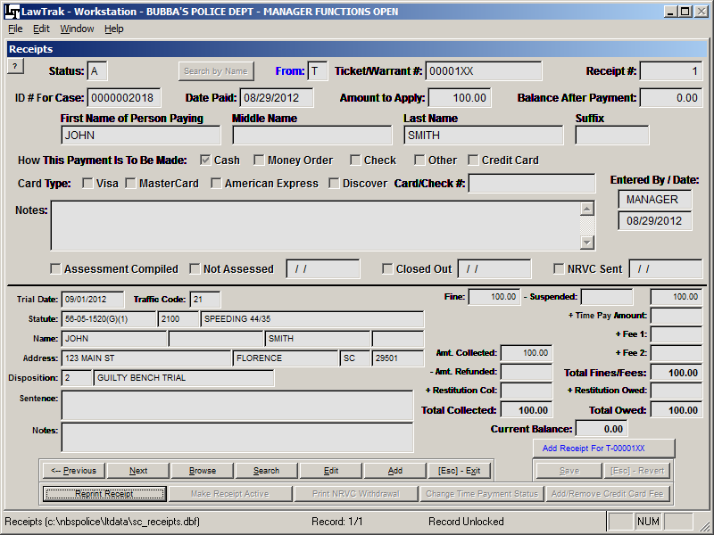

This screen is used to take payments for Traffic Tickets, Warrants, City Arrest Tickets, and Ordinance Summons. In order to take a receipt into LawTrak, the Ticket or Warrant MUST be entered into the system.

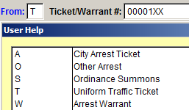
To add a new receipt, press the Add button, and fill in the From and Ticket/Warrant # blocks to bring up the case information. There is an F1 help screen attached to the From box. If you don’t know the ticket number, there is also a button you can press to search by name. This will bring up a listing of tickets that match your name search and allow you to choose one to bring in for receipts. If you enter the Receipts screen from the shortcut on the Courtroom Proceedings screen, there will also be a button to add a receipt for the Ticket/Warrant you just came from in Court.

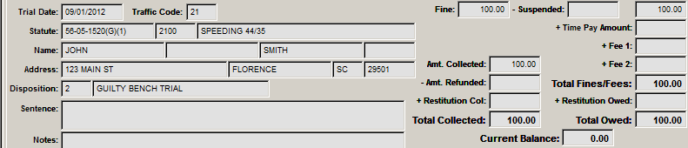

Once the Ticket or Warrant number has been entered, you will see a listing of all financial activities for that case on the bottom part of the Receipts screen, along with the name, disposition, and offense associated with that case. This is simply to make sure you’re working with the correct case.

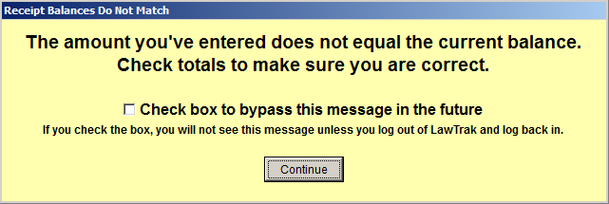

If you enter an amount that does not match the balance due, you will see a warning. This should prompt you to make sure the amount you’ve typed in is correct, and that the case you’re working with is the correct case. The most common reasons for this warning are because a case has not been assigned a fine yet, the case is set up for scheduled time payments, or the fine amount was put in incorrectly in court.

If you are working with a lot of payments that will not equal the amount stated (i.e. a bunch of time payments), you can turn this message off.

By default, the person who was given the ticket will be filled in as the person paying the ticket. If this is not the case, fill in the correct name of the person paying the ticket.

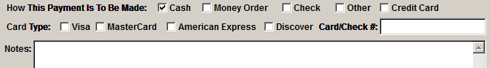

The rest of the information deals with the method of payment, card numbers, check numbers, etc. There is also a Notes field for anything additional you may wish.
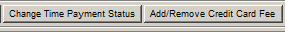
There are a couple of buttons at the bottom of the screen which can be used to add or delete fees associated with the Time Payment Charge, and a Credit Card Fee. These can only be applied at the time the First Receipt is entered. The Change Time Payment Status will add or delete the 3% Time Payment Amount applied to the case. The Credit Card Fee will add or delete the credit card fee you have set up. (See Court / Additional Agency Settings Help Screen for more information)

If a receipt is saved in Offline Mode, you will get a warning. You will also see a status of “O” after you save the receipt. This means that someone has run a Daily Receipt Totals edit and has not closed out the receipt yet. If you need this receipt to be shown on today’s Daily Receipt Totals printout, you can press the Make Receipt Active button at the bottom of the screen. This will force the receipt onto today’s report. (See Daily Receipt Totals Help Screen for more information)

If you put in an incorrect amount on a receipt, the only way to get it back out of the case is to put in an Offsetting Receipt. This usually means adding in a receipt for a negative amount. This receipt will still show up on the Daily Receipt Totals report, and will give auditors a good paper trail to follow. If you do have to use offsetting receipts to correct a problem, please make sure you fill in the appropriate notes.

If a case has been marked as receiving an NRVC notice, a button will activate once the case has been paid in full that will allow you to print the withdrawal part of the NRVC (blue copy) directly from the Receipt page.

Daily Receipt Totals

Top Section: Police – Court
Side Button: Financial

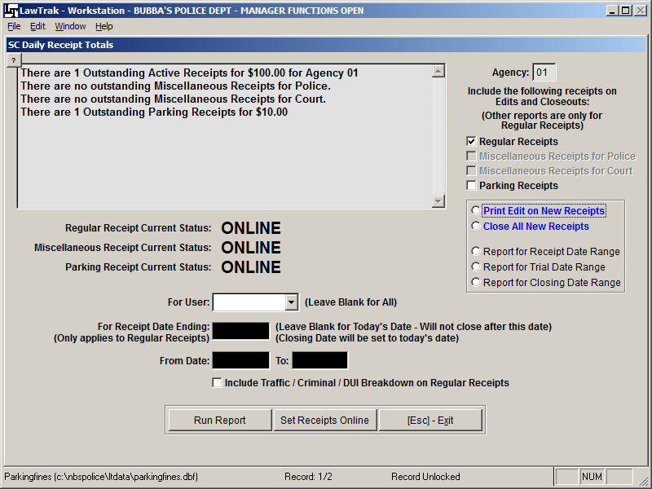

This screen is used to close out receipts taken in from the last time the file was closed out. It is basically closing out the cash drawer. This report is used to verify that the amount put into LawTrak as receipts is the same as the amount of money you actually have on hand.

You have the option to edit and close out Regular, Miscellaneous and Parking Receipts from this screen. There is also the option to run closings on Miscellaneous and Parking Receipts from their respective entry screens.

Aside from the Edits and Closings, there are some miscellaneous reports to print out receipts by different date ranges. These miscellaneous reports are for regular receipts only.

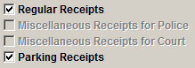
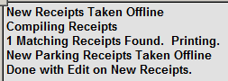
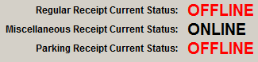
To start the procedure, you need to print out an Edit on New Receipts. You can select any of the categories which have new receipts. Each category will print on its own page. This will print out a listing of all receipts taken in from the last time the receipts were closed. Once you run this edit report, the receipts will be placed Offline. This will keep any new receipts from showing up on today’s report. The totals on this report should match the money you have on hand. If it doesn’t, you need to find out where the differences are and make adjustments.

Adjustments to this report must be made with adjusting receipts. Normally this is done by adding Negative or Positive Receipts as needed for specific cases. When you save a receipt, you will get a message that it is Offline (the status will also be marked with “O”). If you want this receipt to be on today’s report, you must select the option to Make Receipt Active. This will mark the receipt as Active and force it onto today’s report. After your adjustments have been made, run another Edit on the Daily Receipt Totals to make sure everything is correct.

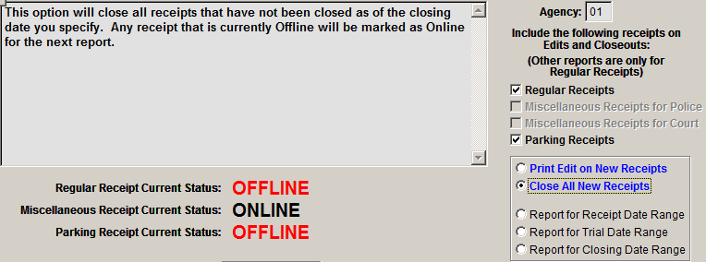

Once your edits are correct, you need to select Close All New Receipts and run the report. This will close out the receipts on your edit report, and will take any offline receipts back to active so they will be included on the next report. A closing report will be printed which should match the money accounted for at the time of closing.

For LawTrak to keep track of when money was taken in and when it was deposited, you must use the Close All New Receipts. On many of the Accounting Reports, LawTrak will use this closing date as the date it was deposited in the bank, and use these dates to calculate your outstanding bonds and the amount of money that is supposed to be in your Court Account. If you do not use the “Blue Options,” LawTrak cannot make the calculations necessary to help us if you get audited.

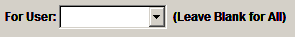
For User: If you have multiple users entering receipts, this option allows you to close out receipts for one specific logon name. If you leave the box empty, LawTrak will close out all receipts no matter who the user is.

For Receipt Date Ending: This option can be used if you want to close out receipts taken in before today’s date. This will help keep daily totals separate if you’re working over multiple days. (Note: This only applies to Regular Receipts. Miscellaneous and Parking Receipts will all close regardless of a Date Ending being present or not.)

By selecting the option to include Traffic / Criminal / DUI Breakdown, you will get an extra report that breaks down regular receipts into the three categories. This will give you the correct amounts to deposit into separate accounts if your court keeps accounts for each type of offense.

Set Receipts Online – Normally the receipts are set back online when you run the Close All New Receipts option. Select this if you want to set the receipts back online without closing new receipts (e.g. the Edit was selected by accident or you only wanted a test edit and are not ready to close). This resets all records back to where they were before you printed the edit.

SC Assessment Report

Top Section: Court
Side Button: Financial

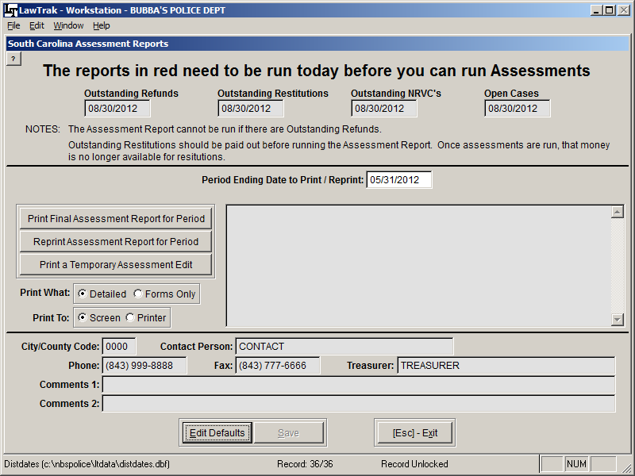

This screen is where you run the monthly Assessment Report. This has also been called the Treasurers’ Report, Disbursement Report, and a number of other terms. There are several reports you need to run before you do the Assessment Report to help you find any problems. Once the Assessment Report has been run for a period, it cannot be run a second time unless you call LawTrak Support. There are four (4) reports listed at the top of the screen that must be run on the same day you run assessments. If the date under these reports is red, you need to run it.

Outstanding Refunds – This can be found under Court – Financial. It will show you any closed cases with overpayments that have not been refunded yet. If there are any outstanding refunds, the Assessment Report will not run.

Outstanding Restitutions – This can be found under Court Financial – Restitution Reports. If you have any restitutions ready to apply, you will need to apply them before the assessments are run. Once money has been applied to restitutions, it will not be assessed. However, if money is assessed first, it will not be available to apply to restitutions. (See the Restitutions Help File for more information)
Outstanding NRVC’s – This can be found under Court – Financial. This will show you all cases which qualify for an NRVC which have not been marked yet. If you mark all qualifying NRVC’s at the time you do dispositions, there should not be any outstanding except possibly time payments which have not paid in full yet. If a case does show up on the report, it usually indicates either a partial payment or an error in entering the fine or receipt.

Open Cases – This can be found under Court – Reports. This will show you all cases which are currently open before today’s date. If you close or continue cases when you do dispositions, there shouldn’t be any open cases when you are done.

Once all of these reports are run, you will be allowed to run the Assessment Report. NOTE: All of these reports must be run on the same day as the Assessment Report.

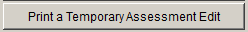
Before you run the final Assessment Report, you should print out a Temporary Assessment Edit. This will allow you to look over the cases and make sure they are in the right classifications to be assessed (traffic in the traffic list, criminal in the criminal list, etc.). If you find any cases in the wrong classification, reopen the cases and recode them correctly.

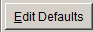
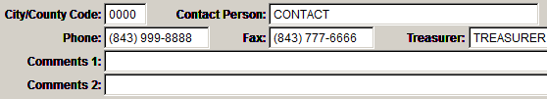
At the bottom of the screen, you will see the information that will print out on the State Assessment Report. You can change this information as needed. The most important field is the City/County Code. This will let the Court Administration know which account to apply the assessments that you send in.

The next period to run is automatically entered when you first get on the screen. If you want to reprint an assessment date, change the Period Ending Date and reprint the report.

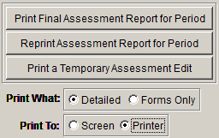
Once all preliminary reports have been run, you can Print the Final Assessment Report for the Period.

Detailed – This option prints out a case-by-case breakdown of all money being assessed, and separates the cases by Traffic, Criminal and DUI. This is the recommended setting.

This will print out all forms needed by the state and your treasurer.

Accounting Main Screen

Top Section: Accounting
Side Button: Data Entry

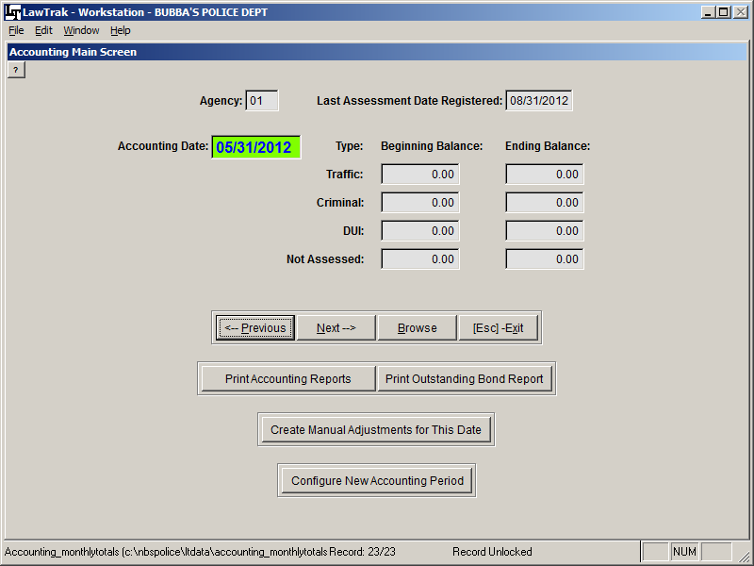

The Accounting Main Screen is used to collect data on all money taken in and disbursed. This piggy-backs off of the monthly State Assessment report.

Before you can run the Monthly Accounting Report, you must run the Monthly State Assessment Report. (See State Assessment Report Help File for more information)

Once assessments have been run, go to the Accounting Main Screen and print out the Outstanding Bond Report. This will find any money that has been paid but not yet assessed. There can be a variety of reasons why money has not assessed:
1) The money could be for a court case in a month that has not been assessed yet.
2) The court case could still be open. A case can only assess money once it is closed.
3) The money is for a restitution that has not been fully paid yet.

The money can also be on the Outstanding Bond List for unknown reasons. If these occur, please call LawTrak Support so we can find out why.

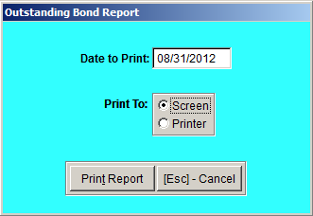
To print out the Outstanding Bonds, press the Print Outstanding Bond Report button, and set the date for the month you just ran for Assessments. That will be the box with the Last Assessment Report Registered.

This will print Outstanding Bond lists for DUI, Traffic and Criminal cases. Most courts will have outstanding bonds every month. What you will be looking for is the reason the bond is outstanding.

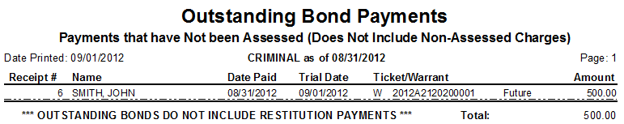

If there is a “Future” flag on the line item, that’s to be expected. In this instance, the case was paid in August, the trial date is set for September, and we’re working on outstanding bonds as of the end of August.

If there is an “Open” flag on the line item, this means the trial date for the case has passed, there is money applied to the case, but the case remains open for some reason. Check on these cases to see if they need to be closed or continued to a new court date.

If there is no flat at all in the line item, there is some sort of problem with the case that does not show up on this report. Please call LawTrak support as soon as possible.

Creating Manual Adjustments
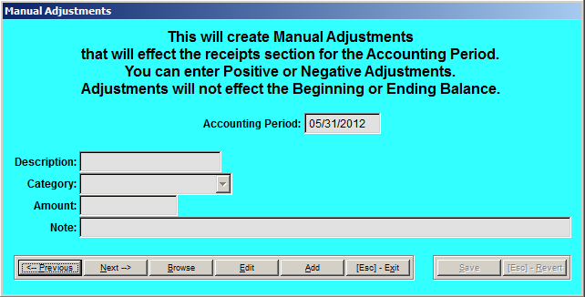
Occasionally you may need to make a Manual Adjustment to the Accounting Report. Please don’t do this unless you really need to, and you know what you’re doing. Normally this will be for something like a rounding error, or a payment of some kind that was not entered into LawTrak

Configuring Receipts

Just a reminder – If you do not run the Daily Receipt Totals closing reports, your Monthly Accounting Reports will not be correct. While the Assessment Report works with the date the receipt came in, the Accounting Report works with the date the receipt was deposited in the bank (closed). If the receipts are never closed, the Accounting Reports will not show any money coming in to the court. (See Daily Receipt Totals for more information)

Configuring New Accounting Periods
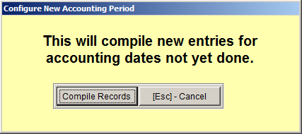
Once the Assessment and the Outstanding Bond Reports check out, press the button to Configure New Accounting Period, and press Compile Records. This will find all period that have not had Accounting Reports run for them yet.
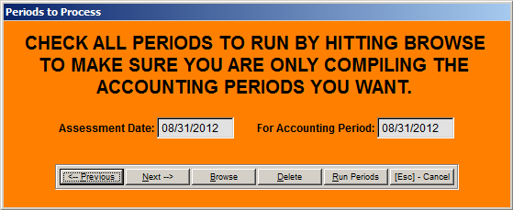
Once you have the periods to process, press Run Periods. This will find all of the money that goes onto the Accounting Reports and compile the entries.
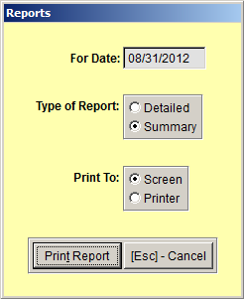

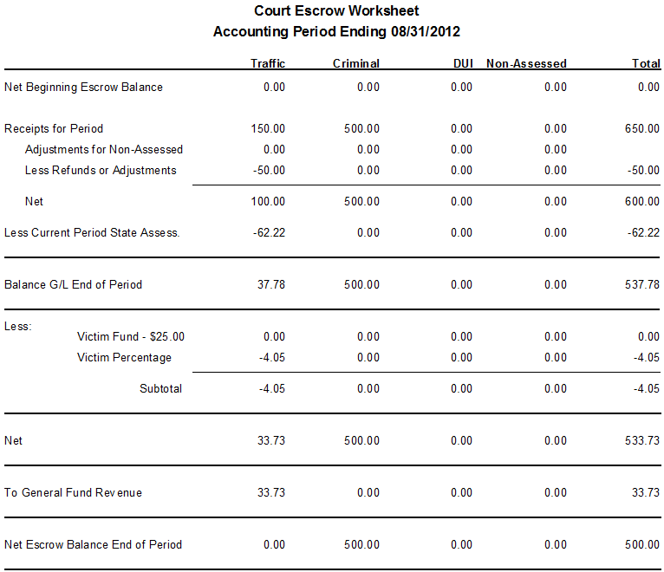

You can print out a Summary of the Accounting Report that will have all of the necessary information for your treasurer. Some of the numbers come from the State Assessment Report for the same period, as well as money deposited, refunds for the period, etc. Notes for any non-standard money collected (TEP, Conditional Discharge, etc.) will print at the bottom of this report.

