INCIDENT REPORTS
Incident Reports

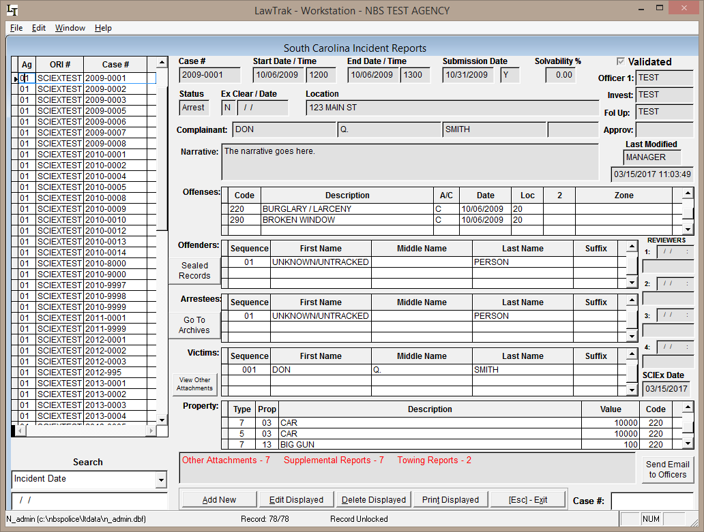

The main Incident Report screen shows all of your incident reports on the left, and gives you most of the main information in the report on the starting screen. All types of supplemental reports are attached from this page.

When adding a new or editing an existing incident report, each section of the report is taken through a walk-through that validates each part of the incident as you put the information in. The validation is to make sure the record is acceptable to be sent to SLED.

Incident Help Notes
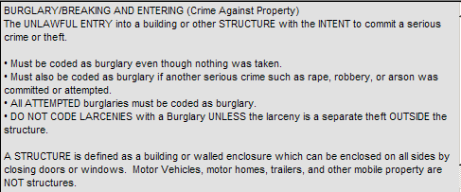
There are two types of Help in the Incident Walk-Through. The first type is notes scattered throughout the walk-through explaining what the field is for and when you can use it. The second type is an explanation inside a “notes” box somewhere on the screen explaining what the field is for, or what your selection means.
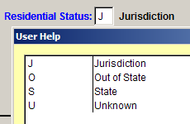
If you are in a data entry box with a blue label, there is a help button (F1) that will bring up the valid codes for that entry box. These codes are controlled by SLED and FBI SCIBRS/NIBRS codes, or can be tied in to some user-defined databases such as an Officer Listing or Inhouse Offense Codes.

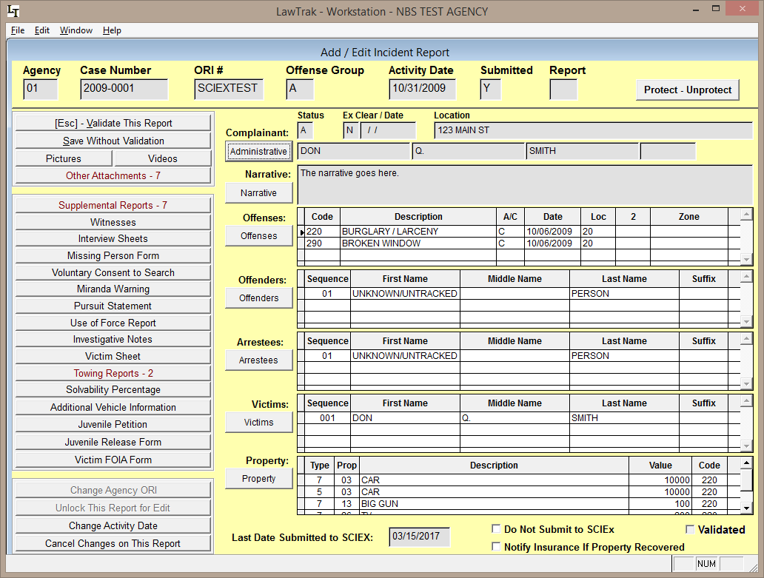

Once you are done with validating and saving the report, there are several things you can do with it. If you need to edit any part of the report (i.e. you find the identity of a previously unknown offender, recover property, make an arrest, etc.), press the button next to the section that needs changing, and that section will be taken back through the walk-through so you can add or change the information as needed.

If you need to attach any supplemental reports, pictures, videos, etc., those buttons are on the left part of the screen.

Protecting an Incident Report

Protecting an incident report keeps anyone from seeing any information or printing the protected report except for the person who protected the report.

SCIEx Submissions

If your agency submits report to SCIEx, you can override the submission. Checking this box will keep the report from going to SCIEx. If it has already been submitted, checking the box and then saving the report will delete the record from SCIEx.

Printing an Incident Report
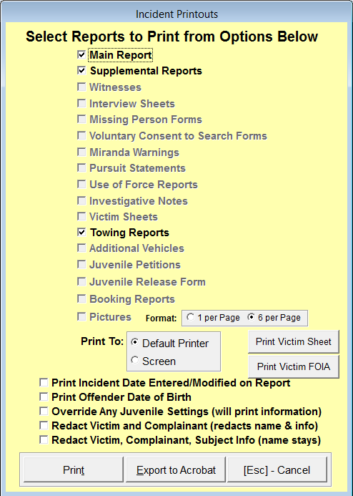
The printout screen allows you to select any part of the incident report that may be available.

By default, the printout will not contain any information for minors, considered by the FBI as under 18. There is, however, and override that will allow minor information to be printed.

There is also an option to redact the victim and complainant.

To use the Export to Acrobat feature, you must call our office and we can walk through setting this up on a workstation. This option will allow you to create a PDF file of the entire case that can be easily sent electronically.

NIBRS Submission – Create File

Top Section: Incidents
Side Button: Lookups

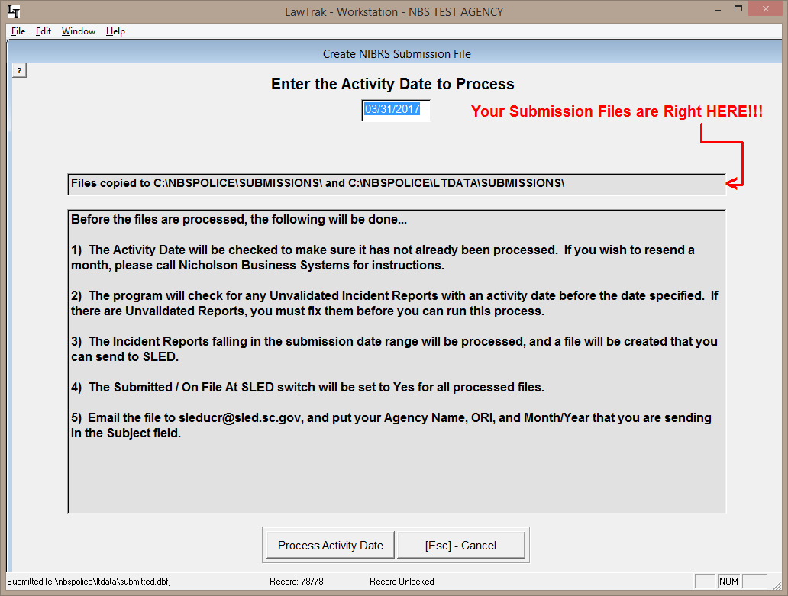

This screen creates the monthly SCIBRS Incident Submission File for SLED.

You can Change or Add a directory to copy the submission file to if you want to keep a backup. Press the option to Change Directory to Copy File and select the path.

If there are any Unvalidated Reports for the selected submission month, the program will print out a listing of unvalidated reports that must be fixed.

Once the file is created, you must still email it to the appropriate SLED email address. The file does NOT automatically submit to SLED.

If there are no reportable incident reports for the month selected, a form will be printed showing a zero-reporting month for your agency that should be faxed to SLED.

